

PROJECT REPORT

**ON**

**ECO-SPARK**

SUBMITTED

TO

**ROURKELA INSTITUTE OF MANAGEMENT STUDIES**

(As a partial fulfilment of the requirement for the award of Degree)

**FOR**

**MASTER IN COMPUTER APPLICATION**

**SUBMITED BY**

**SUSHRITA PARIDA**

REGD NO: 2305260025

**MCA 4TH SEMESTER (2023-2025)**

ROURKELA INSTITUTE OF MANAGEMENT STUDIES

(Affiliated to Biju Patnaik University of Technology)

**1**



**Rourkela Institute of Management Studies**

Rourkela

Department of Computer Science Rourkela Institute of Management Studies Chhend, Rourkela-15, Odisha Phone:0661 2480482

Fax: 91-0661-1480665

Mail: [rkl_rimsgrol@sancharnet.in](mailto:rkl_rimsgrol@sancharnet.in)Visit:

[www.rims-edu.com](http://www.rims-edu.com/)

**CERTIFICATE OF EXAMINATON**

This is to certify that this project report entitled **“ECO-SPARK”** submitted by **SUSHRITA PARIDA** of 4th semester, **Rourkela Institute of Management Studies, Rourkela,** is accepted as partial fulfillment of requirements for the degree in Master in Computer Applications, under **Biju Patnaik University of Technology, Rourkela** this has been verified by us and found be original up to our satisfaction.

Examiner

**2**



**Rourkela Institute of Management Studies**

Rourkela

Department of Computer Science Rourkela Institute of Management Studies, Chhend, Rourkela-15, Odisha

Phone:0661 2480482 Fax:91-0661-1480665

Mail: [rkl_rimsgrol@sancharnet.in](mailto:rkl_rimsgrol@sancharnet.in)Visit:

[www.rims-edu.com](http://www.rims-edu.com/)

CERTIFICATE OF EXAMINATON

This is to certify that this project report entitled **“ECO-SPARK”** submitted by **SUSHRITA PARIDA** of 4th semester, **Rourkela Institute of Management Studies, Rourkela,** is accepted as partial fulfilment of requirements for the degree in Master In Computer Applications, under **Biju Patnaik University of Technology, Rourkela** this has been verified by us and found be original up to our satisfaction.

Examiner

**3**



**Rourkela Institute of Management Studies**

Rourkela

Department of Computer Science Rourkela Institute of Management Studies Chhend, Rourkela-15, Odisha Phone:0661 2480482

Fax:91-0661-1480665

Mail: [rkl_rimsgrol@sancharnet.in](mailto:rkl_rimsgrol@sancharnet.in) Visit: [www.rims-edu.com](http://www.rims-edu.com/)

CERTIFICATE

This is to certify that this project entitled **“ECO-SPARK”** has been and submitted by **SUSHRITA PARIDA,** M.C.A 2023-2025, **Rourkela Institute of Management Studies, Rourkela,** has been examined by us.

She is found fit and approved for the award of **“Master in Computer Application “**Degree.

To the best my knowledge this work has not been submitted for the award of any other degree.

I wish all success in his life.

DEAN ACADEMIC RIMS, ROURKELA

**4**



Prof. Bibhudendu Panda Head of The Department, MCA

Rourkela Institute of Management Studies, Rourkela

CERTIFICATE

This is to certify that **SUSHRITA PARIDA** student of **M.C.A, Rourkela Institute of Management Studies, Rourkela, Odisha** ofSession 2023-2025 has completed the project successfully.

I wish all success in his life

**(Prof. Bibhudendu Panda)**

**5**



DECLARATION

I, **SUSHRITA PARIDA**, hereby declare that the project report entitled “**ECO-SPARK**” is of my work. The above work I submitted to “**Biju PatnaikUniversity of Technology, Rourkela”** for the award of **“Master in Computer Applications**” Degree.

To the best of my knowledge, this work has not been submitted or published anywhere for the award of any degree.

SUSHRITA PARIDA

**6**



ACKNOWLGEMENT

I would like to express my gratitude to **Mr. Rashmi Kanta Das and Mr. Smruti Ranjan Nayak** for his guidance and support during the project work.

I am deeply indebted to **Rourkela Institute of Management Studies, Chhend, Rourkela,** for providing me an opportunity to undertake a project work entitled **“ECO-SPARK”.**

I am grateful to my project guide **Prof. Bibhudendu Panda** without his guidance it would not have been possible on my part to complete the project.

I acknowledge the help and co-operation received from all my team members in making this project.

I consider myself fortunate that I have successfully completed this project; I acknowledge my sincere gratitude to all those works and ideas that had helped me in writing this project.

SUSHRITA PARIDA

**University Roll No: 2305260025 MCA (2023-2025)**

**Rourkela Institute of Management Studies, Rourkela.**

**7**

ABSTRACT

The EcoSpark project is designed to promote sustainable energy solutions by offering a comprehensive e-commerce platform specializing in eco-friendly products. With the increasing demand for renewable energy solutions, EcoSpark aims to bridge the gap between consumers and reliable, high-quality green energy products. The platform features a range of solar-powered and energy-efficient products, including chargers, power banks, flashlights, garden lights, inverters, solar fans, and LED bulbs. These products are carefully curated to provide affordable and sustainable alternatives to traditional energy-consuming devices. Our primary objective is to develop a user-friendly, responsive, and secure e-commerce experience that allows customers to browse products, compare specifications, read reviews, and make purchases seamlessly. The platform incorporates a dynamic product catalog, an advanced search, and an admin dashboard for managing inventory and sales. The project follows a structured development lifecycle using agile methodologies to ensure efficiency and adaptability. The technology stack includes Html, Css, JavaScript for the front end, Java for the backend, and MySQL for data management, ensuring robust performance and scalability. Through this project, EcoSpark aims to make a significant impact in the renewable energy sector by providing an accessible and convenient online marketplace for green technology. Future enhancements include AI-driven product recommendations, a dedicated mobile application, and expanded product offerings to further promote sustainable energy adoption.

**8**

GANTT CHART

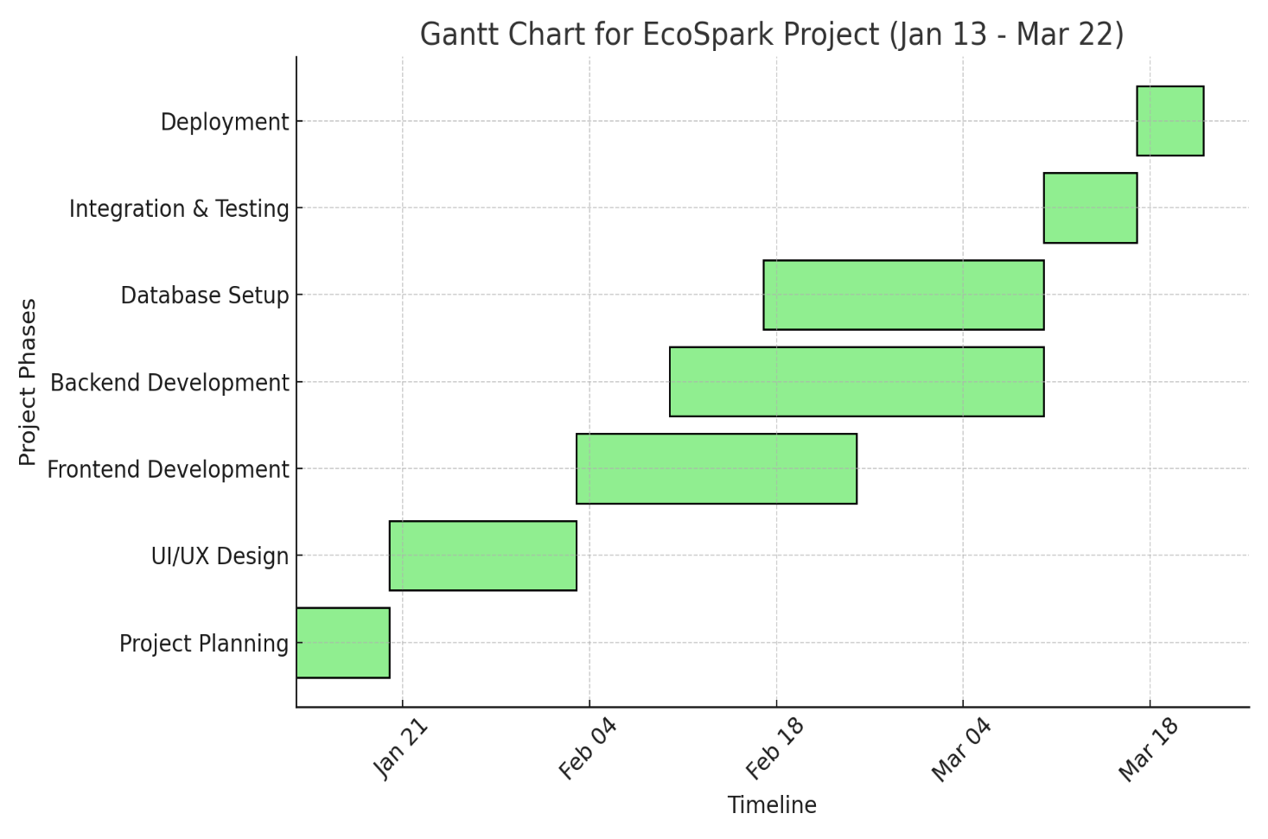

**9**

**Table of Contents**

|  |  |  |
| --- | --- | --- |
| **Sl.No.** | **Title** | **Page No.** |
| 1 | FRONT PAGE | 01 |
| 2 | CERTIFICATION OF EXAINATION | 02 |
| 3 | CERTIFICATE | 03 |
| 4 | DECLARATION | 04 |
| 5 | ACKNOWLGEMENT | 05 |
| 6 | ABSTACT | 06 |
| 7 | GANTT CHART | 08 |
| 8 | INTRODUCTION | 11-15 |
| 9 | LITERETURE SURVEY | 16-17 |
| 10 | PROJECT PLANNING | 18-20 |
| 11 | ENVIRONMENT SETTINGS | 21-36 |
| 12 | SELECTED SOFTWARE OR PLATFORM | 37-55 |
| 13 | CODING | 59-78 |
| 14 | SYSTEM TESTING | 79-80 |
| 15 | CONCLUSION AND FUTURE SCOPE | 81 |
| 16 | REFERENCES | 82 |

**10**

# CHAPTER-1

###### INTRODUCTION

**11**

**1.1 Preface**

The EcoSpark project is designed to provide an efficient, affordable, and sustainable solution for consumers looking for renewable energy products. With an increasing global focus on green energy and sustainability, EcoSpark aims to offer a seamless e-commerce experience that caters to the growing demand for solar-powered and energy-efficient products.

The platform is built to simplify the buying process, offering:

* + - A well-structured product catalog with detailed descriptions, images, and technical specifications.
    - Customer reviews and ratings, helping buyers make informed decisions based on real user experiences.
    - An intuitive admin dashboard, enabling sellers to efficiently manage inventory, track sales, and analyze performance metrics.

**1.2 Understanding the Problem Statement**

Before diving into the implementation of the EcoSpark project, it is essential to understand the problem we aim to solve and the key challenges in the renewable energy market.

Broadly, the renewable energy product market faces two major challenges:

* Product Availability & Accessibility – Many consumers find it difficult to locate reliable, high-quality solar-powered products in a single online marketplace.
* User Experience & Trust – Lack of verified customer reviews, secure transactions, and seamless shopping experience discourages buyers from investing in green energy solutions.

To bridge these gaps, EcoSpark focuses on developing a dedicated e-commerce platform that simplifies the buying process and provides a trusted, user-friendly environment for purchasing sustainable energy products.

**1.3 Motivation for Work**

In today’s rapidly evolving market, businesses must prioritize customer convenience, accessibility, and efficiency to stay competitive. The growing demand for renewable energy solutions highlights the need for a dedicated platform where consumers can easily access high-quality solar-powered products. However, many face challenges such as market fragmentation, lack of reliable product sources, and complex purchasing processes.

EcoSpark aims to bridge this gap by providing a comprehensive e-commerce platform that simplifies the process of discovering, purchasing, and managing renewable energy products. Through seamless transactions, real-time inventory management, and an intuitive user interface, EcoSpark ensures that customers have easy access to cost-effective, high-performance energy solutions.

Moreover, as the global focus on sustainability intensifies, consumers seek trusted platforms that align with their commitment to reducing carbon footprints. EcoSpark leverages modern technology and a data-driven approach to enhance the efficiency of product availability, order processing, and customer engagement.

By addressing the challenges associated with purchasing solar-powered products online, EcoSpark promotes environmental consciousness while ensuring affordability, accessibility, and long-term reliability in the renewable energy sector.

**1.4 Project Overview**

Renewable energy has become a crucial component of sustainable development, with solar energy leading the way as an accessible and eco-friendly alternative to traditional power sources. However, many consumers struggle to find reliable, high-quality, and cost-effective solar-powered products due to a fragmented market and limited availability.

EcoSpark is an e-commerce platform designed to bridge this gap by offering a comprehensive marketplace for renewable energy solutions. It provides a user-friendly interface where customers can browse, compare, and purchase solar-powered chargers, LED lights, inverters, garden lights, and other energy-efficient products.

The platform is divided into two main components:

* E-Commerce Website – A fully responsive website that allows users to explore and purchase products with ease. Customers can filter items based on price, category, and specifications, ensuring a seamless shopping experience. Real-time inventory tracking ensures that users have access to updated product availability.
* Admin Dashboard – A powerful backend system that enables administrators to manage product listings, stock levels, and orders efficiently. The dashboard provides real-time insights into sales and inventory trends, helping businesses make data-driven decisions for better management and scalability.

**12**

As the demand for sustainable energy solutions continues to grow, EcoSpark aims to provide a trusted, efficient, and innovative platform that empowers individuals and businesses to make eco-friendly choices while ensuring a smooth and secure shopping experience.

**1.5 Purpose**

The EcoSpark e-commerce platform is designed with the purpose of making renewable energy solutions more accessible, affordable, and reliable for consumers. As the world increasingly shifts toward sustainable energy alternatives, individuals and businesses require a trusted marketplace where they can purchase high-quality solar-powered products with ease.

Traditional methods of sourcing solar chargers, LED lights, inverters, and other energy-efficient products often involve inconvenient offline shopping, lack of product comparisons, and limited customer support. EcoSpark aims to eliminate these challenges by providing a centralized online marketplace with a seamless shopping experience.

The demand for eco-friendly energy solutions has grown significantly due to rising concerns about climate change, high electricity costs, and environmental sustainability. However, many consumers struggle to find a reliable platform that offers a wide selection of verified solar-powered products.

The purpose of the EcoSpark project is to revolutionize the way people access and purchase sustainable energy solutions. By leveraging technology, e-commerce capabilities, and modern business strategies, EcoSpark will empower individuals and businesses to transition towards a greener and more energy-efficient future.

**1.6 Project Scope**

The EcoSpark e-commerce platform is designed to streamline the buying and selling of renewable energy products, catering to both individual consumers and businesses. The primary objective of this project is to create a user-friendly, scalable, and efficient online marketplace where customers can easily explore, compare, and purchase solar-powered products such as chargers, LED lights, inverters, and garden lights.

* The project is divided into two key components:  
  E-commerce Website – A responsive online platform that enables customers to browse and purchase solar-powered products seamlessly.

**13**

* Admin Dashboard – A backend management system for businesses to monitor inventory, update product listings, and track sales performance.

**1.7 Project Goals and Objectives**

1.3.1 Goals

The goal of the EcoSpark e-commerce platform is to provide a user-friendly, scalable, and secure marketplace for renewable energy products. With the rising demand for eco-friendly solutions, consumers often struggle to find affordable and reliable solar-powered products. This project aims to bridge that gap by offering a seamless shopping experience and a robust inventory management system for businesses.

By promoting solar-powered solutions, EcoSpark supports sustainability and encourages a shift toward green energy adoption.

1.3.2 Objectives

* Encouraging Sustainability-  
  Promote solar-powered products that help reduce carbon footprints and dependence on non-renewable energy sources.
* Enhancing Accessibility-  
  Create a centralized platform where consumers can easily browse, compare, and purchase solar products.
* Supporting Business Growth-  
  Provide businesses with tools to manage sales, inventory, and operations efficiently through an admin dashboard.
* Smart Inventory & Order Management-  
  Enable businesses to track stock levels, monitor trends, and optimize supply chains.
* Seamless User Experience-  
  Offer a secure, mobile-friendly, and intuitive shopping experience.

**1.8 Requirement Specifications**

The development of the EcoSpark e-commerce platform requires a combination of hardware and software components to ensure a smooth, efficient, and scalable system. The specifications outlined below define the necessary requirements for optimal performance, security, and seamless user experience.

1.8.1 Hardware Specifications

To ensure the platform runs efficiently and handles multiple operations simultaneously, the following hardware specifications are recommended:

* RAM: Minimum 6GB or higher for smooth multitasking and efficient performance.
* HDD: 1TB storage capacity to store logs, system files, and other necessary data.
* SSD: Minimum 512GB SSD for faster boot times, improved performance, and quick data retrieval.

**14**

* Processor: Intel Core i5 or higher to handle database queries, server-side logic,
* and frontend rendering efficiently.

These specifications ensure that the system performs optimally, minimizes lag, and supports real-time operations like inventory management and order processing.

1.8.2 Software Specifications

The EcoSpark e-commerce platform is built on modern web technologies to ensure a scalable, user-friendly, and secure shopping experience.

Operating System: Compatible with Windows 7, Windows 10, and Windows 11 to ensure ease of deployment across various devices.

Frontend Technologies:

HTML, CSS, JavaScript – For structuring, styling, and enhancing user interactivity.

Backend Technologies:

Java 17 – A robust programming language used for backend logic, API development, and data processing.

SpringBoot Framework – A high-level web framework that promotes rapid development, security, and scalability.

Database:

MySQL – For storing and managing user data, inventory, orders, and transactions securely.

Version Control:

GitHub – Used for collaborative development, source code management, and version tracking.

**15**

# CHAPTER-2

LITERETURE SURVEY

The literature survey serves as the foundation for understanding existing research, methodologies, and technologies related to e-commerce platforms for renewable energy products. This section explores the evolution of e-commerce, renewable energy markets, and technological advancements in building an efficient, scalable, and sustainable platform like EcoSpark.

2.1 Evolution of E-Commerce

E-commerce has revolutionized the way businesses operate by providing convenient, accessible, and global marketplaces. Since the early 2000s, online retail platforms such as Amazon, eBay, and Alibaba have set the stage for digital commerce. With the adoption of mobile shopping, AI-driven recommendations, and cloud computing, businesses have moved towards automated inventory management, personalized marketing, and seamless payment systems.

For sustainable products, e-commerce platforms like Tesla’s online store, SunPower, and Ecoflow have emerged, making solar and green energy solutions more accessible. However, challenges remain in terms of product standardization, customer trust, and awareness.

2.2 Growth of Renewable Energy Market

With increasing concerns over climate change and carbon emissions, governments and organizations worldwide have been promoting renewable energy solutions. The International Energy Agency (IEA) reports that solar power adoption has grown by over 20% annually, driven by government incentives, lower production costs, and increased environmental awareness.

However, accessibility remains an issue. Traditional offline distribution channels for solar-powered products often involve middlemen, higher costs, and limited product availability. By integrating solar energy solutions into a dedicated e-commerce platform, EcoSpark aims to bridge the gap between manufacturers and end consumers, providing a direct, affordable, and trustworthy shopping experience.

2.3 Technologies in E-Commerce Development

To develop a scalable and efficient e-commerce platform, several key technological innovations are considered:

**16**

1. Web Frameworks & Programming Languages
   * Spring Boot(JAVA 17) – A high-level web framework known for security, scalability, and rapid development.
   * JavaScript – Used for creating dynamic, interactive, and mobile-friendly user interfaces.
2. Database & Storage Solutions
   * MySQL– Provide a robust, flexible, and secure data management system for handling user accounts, product catalogs, inventory, and transactions.
3. Cloud Hosting & Deployment
   * Modern e-commerce solutions rely on cloud platforms (AWS, Azure, or Google Cloud) to ensure scalability, security, and seamless uptime.
4. AI & Machine Learning Integration
   * AI-driven recommendation systems enhance user engagement by suggesting relevant solar products.
   * Predictive analytics help businesses optimize stock levels and demand forecasting.
   * From the literature survey, it is evident that e-commerce platforms for renewable energy products are still an emerging market with significant potential. By leveraging modern technologies, providing a seamless user experience, and addressing key challenges in accessibility and trust, EcoSpark aims to fill the gap in the industry and promote the adoption of sustainable energy solutions.

**17**

# CHAPTER-3

### PROJECT PLANNING

Project planning is essential for the smooth execution of the EcoSpark e-commerce platform. A structured roadmap with defined milestones ensures timely development and high-quality results. The project consists of several key phases, each contributing to the platform's success.

3.1 Project Phases and Timeline

The EcoSpark development process is divided into five major phases, each focusing on a crucial aspect of the project.

3.1.1. Project Planning (Jan 13 – Jan 20)

* Objective: Define project scope, objectives, and technical requirements.
* Key Activities: Understanding business goals and defining the project scope.
* Conducting research on market trends in eco-friendly products.
* Identifying target customers and their shopping behavior.
* Selecting the technology stack for frontend, backend, and database.
* Establishing the project workflow and setting milestones.

Deliverables:

* A finalized project roadmap with defined sprints.
* Technology stack and architecture selection.
* Clear documentation of project scope and features.

3.1.2. UI/UX Design (Jan 21 – Feb 4)

* Objective: Develop an intuitive, visually appealing user interface for the e-commerce platform.
* Key Activities: Creating wireframes for the homepage, product pages, and cart.
* Designing high-fidelity prototypes for desktop and mobile views.
* Conducting usability testing to refine the design.
* Ensuring accessibility and responsive design principles.

**18**

Deliverables:

* Finalized UI/UX designs for all e-commerce pages.
* Interactive prototypes for user testing.
* Approved design system for frontend development.

3.1.3 Frontend Development (Feb 5 – Feb 25)

* Objective: Build a responsive and interactive user interface.
* Key Activities: Implementing the homepage, product listing, and product detail pages.
* Developing the shopping cart, checkout, and order confirmation pages.
* Ensuring responsiveness across all screen sizes and devices.
* Adding animations and interactive elements for a seamless user experience.
* Optimizing frontend performance for fast loading times.

Deliverables:

* Fully developed and responsive frontend interface.
* Cross-browser and cross-device compatibility testing reports.
* Integration-ready frontend components.

3.1.4. Backend Development (Feb 15 – Mar 10)

* Objective: Develop a scalable and secure backend to support the platform.
* Key Activities: Setting up the backend server and API endpoints.
* Implementing user authentication (registration, login, and role management).
* Managing inventory, product listings, and order processing.
* Developing an admin dashboard for order and product management.
* Securing payment processing and transaction data.

Deliverables:

* Functional backend with RESTful API endpoints.
* Secure authentication system.
* Payment gateway integration.

**19**

3.1.5. Database Setup (Feb 20 – Mar 5)

* Objective: Create a well-structured and optimized database for data management.
* Key Activities: Designing a database schema for users, products, and transactions.
* Implementing efficient data storage and retrieval mechanisms.
* Ensuring backup and recovery solutions for data security.
* Optimizing database performance with indexing.

Deliverables:

* Fully structured and optimized database.
* Secure data handling and storage mechanisms.
* Scalable database setup for future expansion.

3.2 Expected Outcomes

By following this structured project plan, the EcoSpark e-commerce platform aims to achieve the following:

* Fully Functional E-Commerce Platform – A secure, scalable, and feature-rich online store for eco-friendly products.
* Optimized User Experience – A well-designed UI/UX for seamless shopping across different devices.
* Efficient Product & Order Management – A backend system that ensures smooth product listings, inventory tracking, and secure transactions.
* Scalability for Future Growth – A platform that can expand with new product categories and services as needed.

The EcoSpark project follows a well-structured approach to ensure efficient execution and high-quality results. With clearly defined phases and deliverables, the project is set for success.

**20**

# CHAPTER-4

ENVIRONMENT SETTINGS

###### Prerequisite

* Java 17 or above
* HTML, CSS
* JAVASCRIPT
* SpringBoot and it’s Dependencies:
  1. SpringWeb
  2. Spring JPA
  3. Spring Security
  4. Spring DevTool
  5. Validation
  6. Thymeleaf
  7. Mysql Driver
  8. Lombok
* MySql
* Git and GitHub
* Microsoft Visual Studio Code
* Visual Studio code Extensions:

 Extension pack for java

2. Spring Boot Extension pack

3. Html, CSS Extension pack

4. JavaScript Extension pack

**21**

Developed any Project need a IDLE (Integrated Development Environment), so Developer can easily Create, Run, Compile and Execute Programs.

**How to Install Visual Studio Code on Windows?**

Firstly, download the Visual Studio Code installer for Windows. Once it is downloaded, run the installer (*VSCodeUserSetup-{version}.exe*). It will only take a minute.

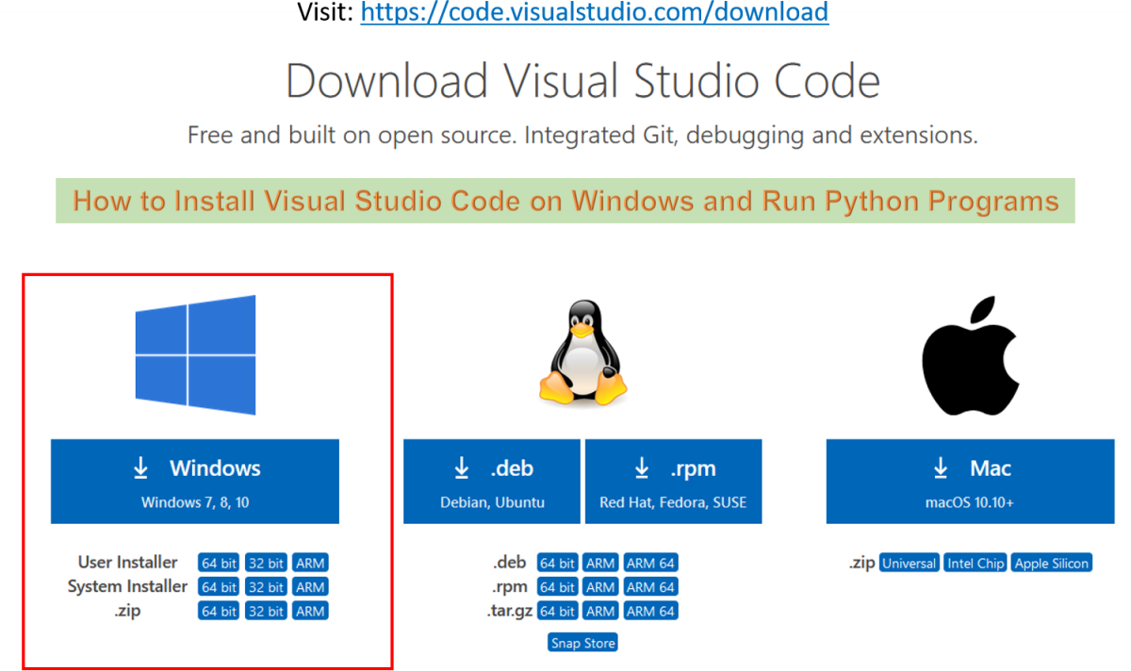

Then double Click on Download folder .exe file and Follow the step by step instruction Process .

Secondly, accept the agreement and click on next.

**22**



Thirdly, click on “**create a desktop icon**” so that it can be accessed from desktop and click on Next.

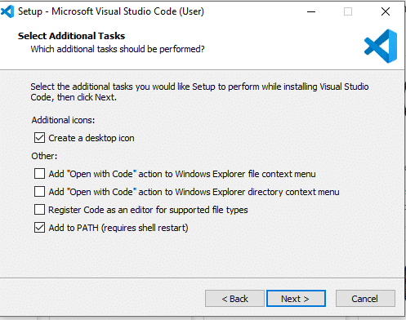

After that, click on the install button.

**23**

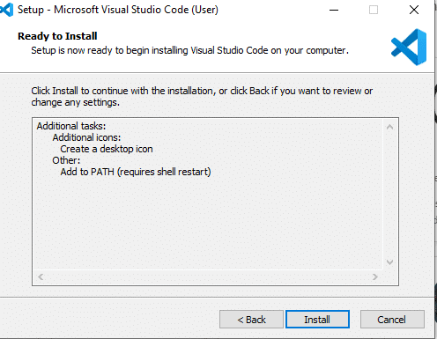

Finally, after installation completes, click on the finish button, and the visual studio code will get open.

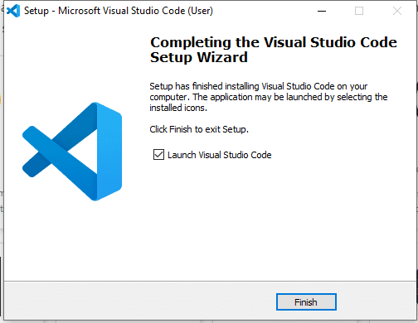

**24**

**25**

**How to initiate SpringBoot by adding Dependencies -:**

**Method 1: Using Spring Initializr(Recommended)**

1. Go to Spring Initializr

Openhttps://start.spring.io/

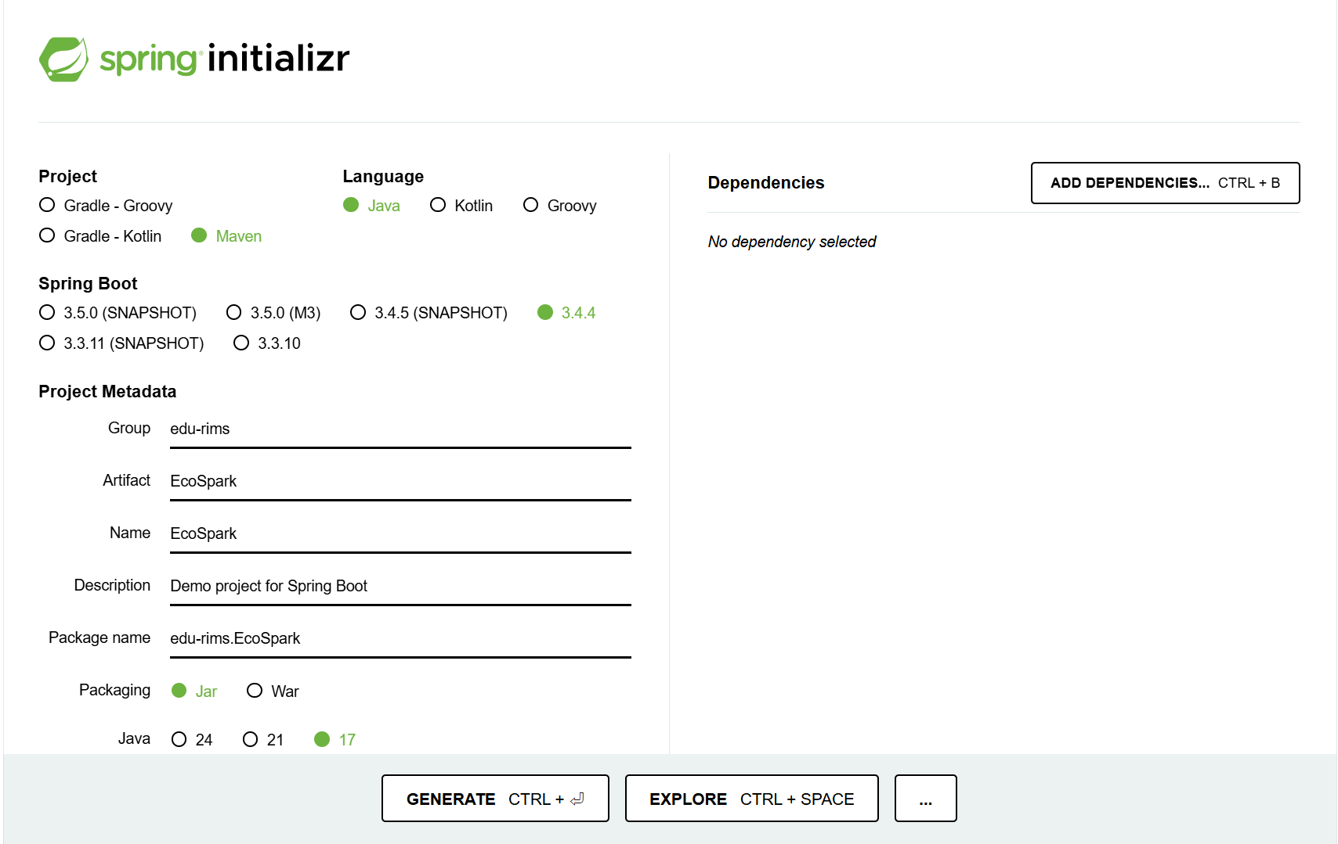

1. Select Project Type & Language

o Project: Maven (or Gradle if you prefer)

o Language: Java

o Spring Boot Version: Latest stable version (e.g., 3.x.x)

1. Fill in Project Metadata

o Group: edu-rims (or your package name)

o Artifact: EcoSpark (name of your project)

o Name: EcoSpark

o Package Name: Project for Spring Boot

o Packaging: Zip

o Java Version: 17 (or as per your system compatibility)

1. Add Dependencies

Click on "Add Dependencies" and search for each dependency:

o ✅ Spring Web (For building REST APIs and web applications)

o ✅ Spring Data JPA (For database interaction using JPA)

o ✅ Spring Security (For authentication & authorization)

o ✅ Spring Boot DevTools (For live reload & development support)

o ✅ Spring Boot Validation (For data validation)

o ✅ Thymeleaf (For frontend templating)

o ✅ MySQL Driver (For database connectivity)

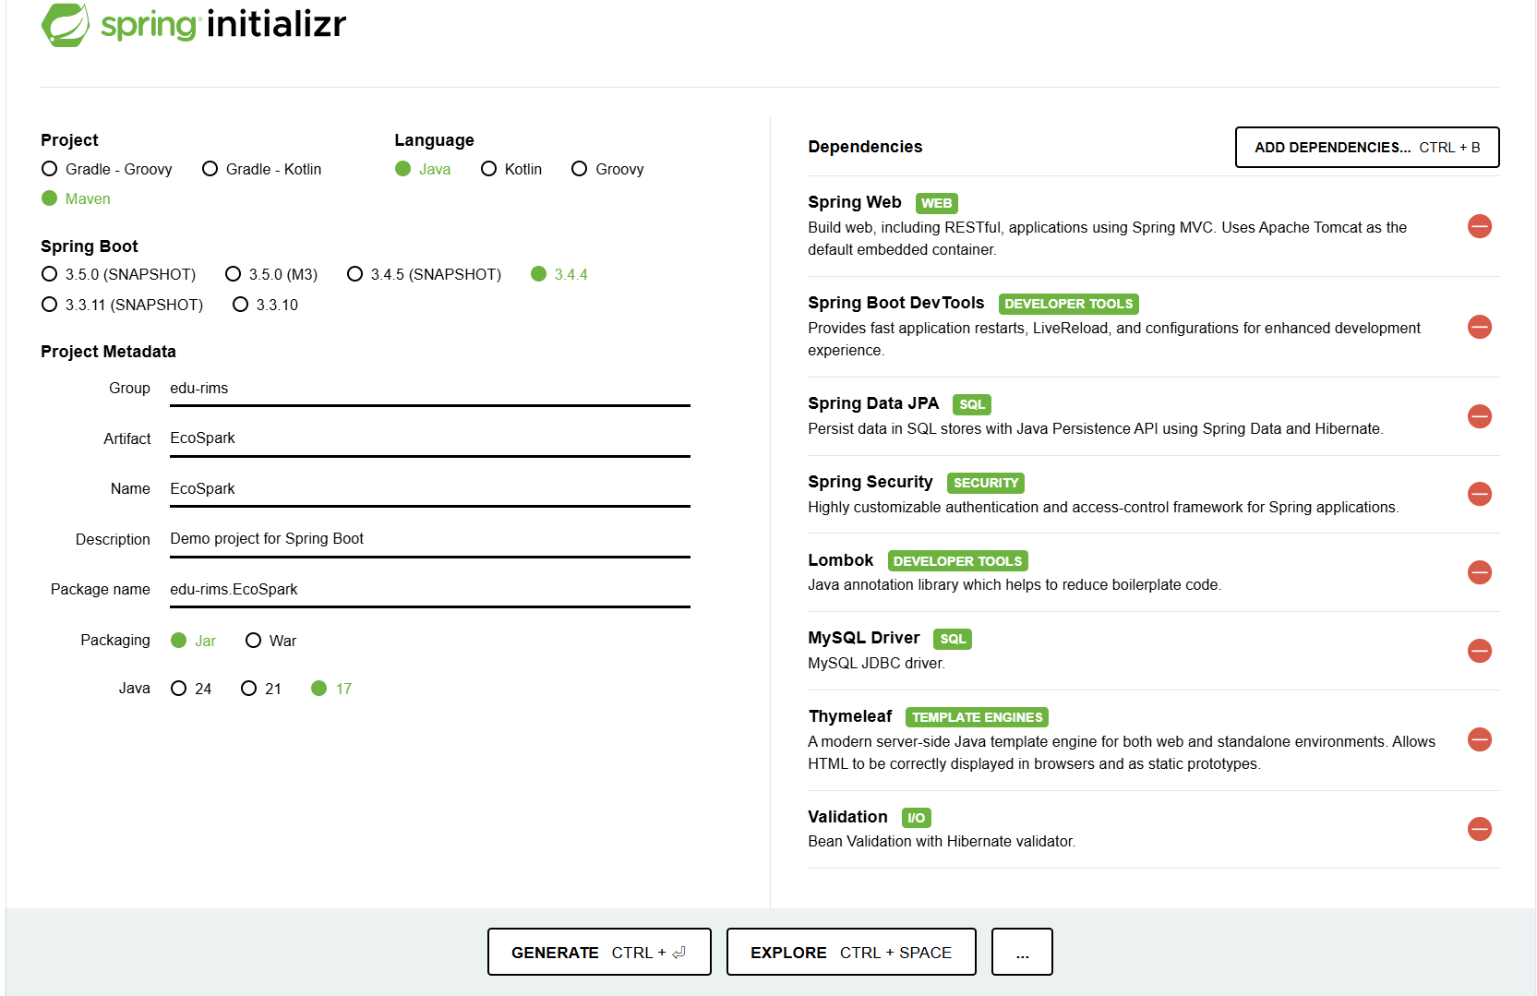o ✅ Lombok (For reducing boilerplate code like getters & setters)

**26**

5. Generate the Project

o Click on Generate

o It will download a zip file

o Extract the zip and open the project in IntelliJ IDEA, Eclipse, or VS Code

**Install Git**

1.Download Git

oGo to the official Git website.

o Download the latest version for your operating system (Windows, macOS, or

Linux).

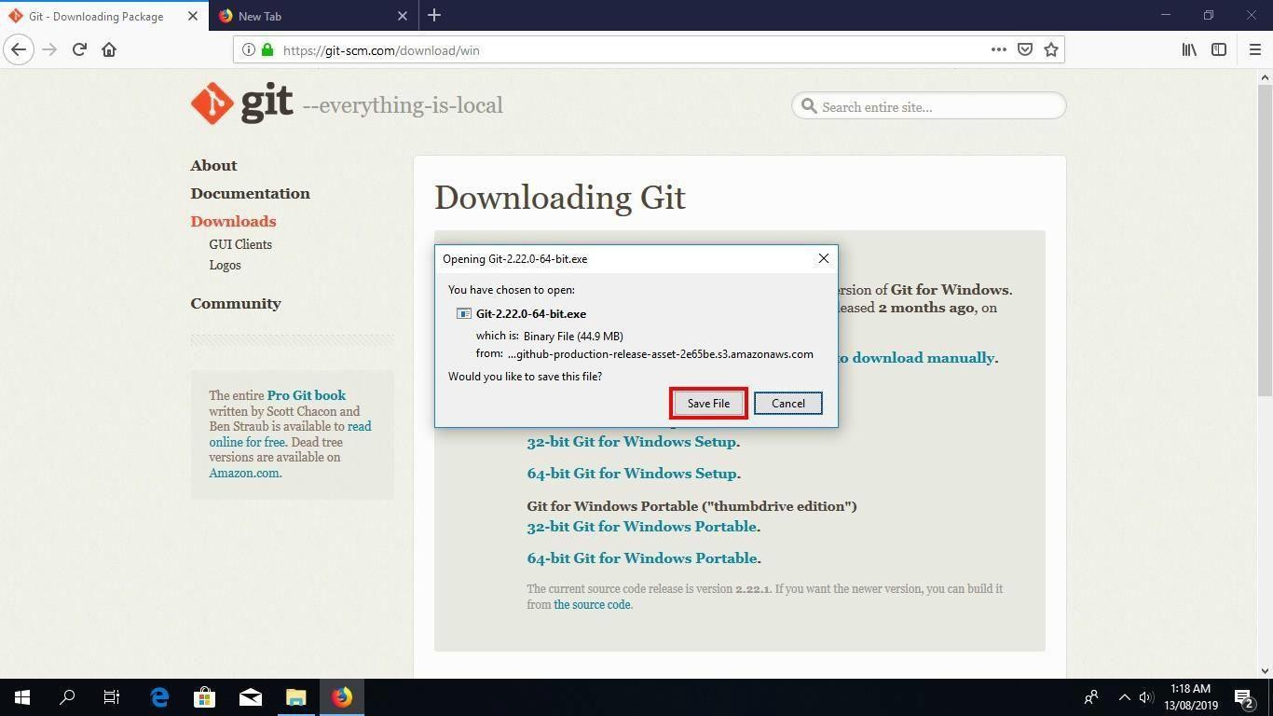

Click on “Save File” to start downloading the executable.

2. Install Git Bash

Run the Installer

Once you have downloaded the Git Click “Next” after you have read the license Bash executable,

**27**

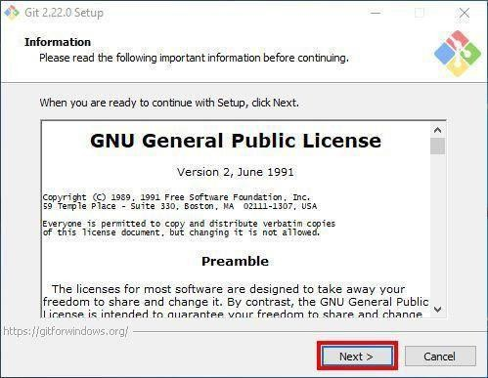

**28**

3. Click “Next” after you have read the license.

Step 4: Select Destination Location Permalink

Next, select the location you want to install Git Bash. I would recommend you just leave the default option as it is, and click “Next”.

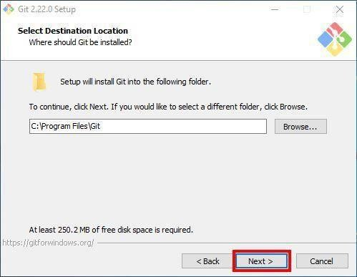

Step 5: Select Components

Choose the components you want to install, or you can just proceed with the default

options and click “Next”. I prefer selecting the “Additional icons” component which

creates a Git Bash shortcut on the desktop.

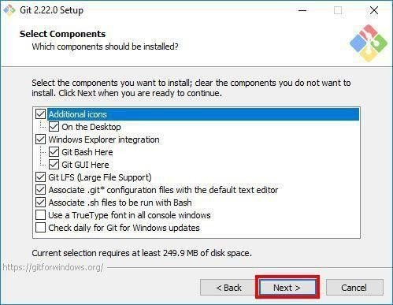

**29**

Step 6: Select Start Menu Folder

You can change the name of start menu folder here if you want, or just leave the default name and click “Next”.

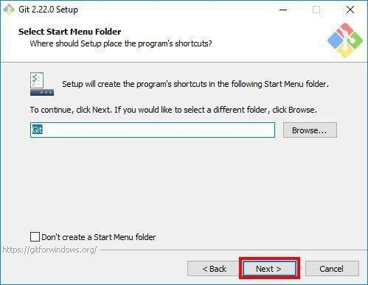

Step 7: Choose the Default Editor used by Git

Next, select the default editor for Git to use. Choose the one you like and click “Next”. I would recommend you proceed with Nano or Notepad++. Don’t proceed with the default option “Vim” as it has a steep learning curve.

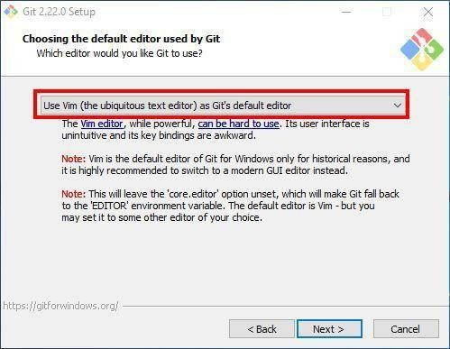

**30**

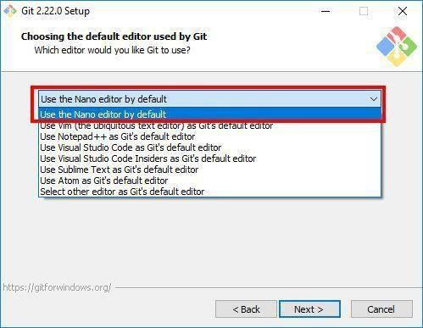

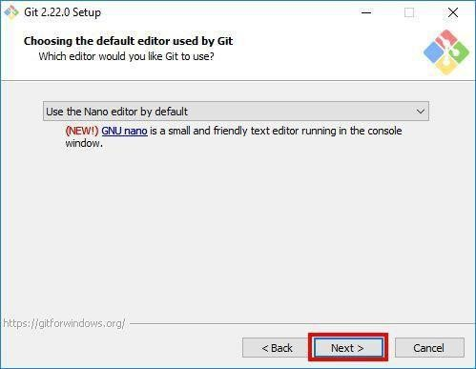

**31**

Step 8: Adjust your PATH Environment

Choose the option you want depending on where you want to use Git and click “Next”.

Select “Use Git from Git Bash only” option if want to run Git and Bash commands from GitBash only. This means that you won’t be able to run Git commands such as git status on Windows Command Prompt or Powershell. They will only be found on Git Bash.

Select “Git from the command line and also from 3rd-party software” option if you want to run Git commands on Windows Command Prompt or Powershell.

Notice: Bash commands won’t work on Command Prompt or Powershell with this option, but only Git commands will work.

Tip: If you need run bash commands, you will have to open the Git Bash. So go ahead with this option if that is what you want.

Select “Use Git and optional Unix tools from the Command Prompt” option if you want to use both Git and Bash commands on Windows Command Prompt or Powershell. This option will override some default Windows Command Prompt tools like find and sort. I don’t use CMD or Powershell that much to worry about that. So I will go ahead with this option by clicking “Next”.

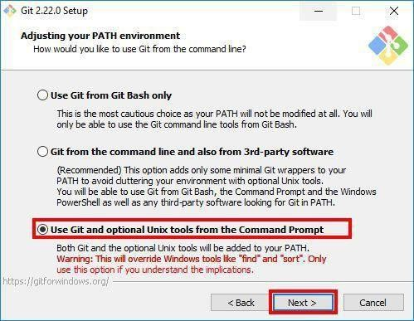

Step 9: Choose HTTPS Transport Backend Permalink

Next, select “Use the OpenSSL library” and click “Next”

**32**

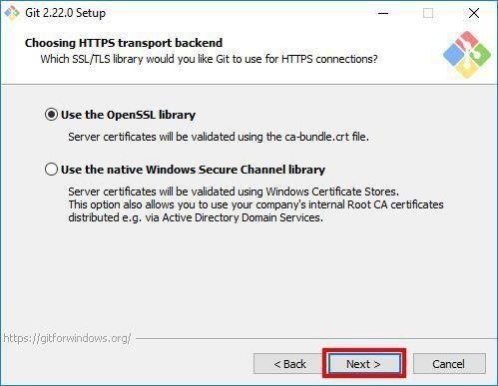

Step 10: Configure the Line Ending Conversions

Select how Git should treat line endings in text files. It’s probably safe to go with the default option “Checkout Windows-Style, commit Unix-style line endings”. Click “Next” to proceed.

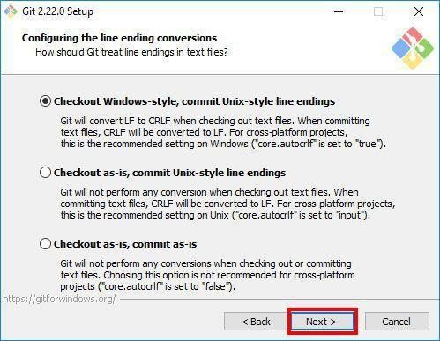

**33**

Step 11: Configure the Terminal Emulator to use with Git BshPermalink

Next, select the terminal emulator you want Git Bash to use. I will proceed with the default option “Use MinTTY(the default terminal of MSYS2) and click “Next”.

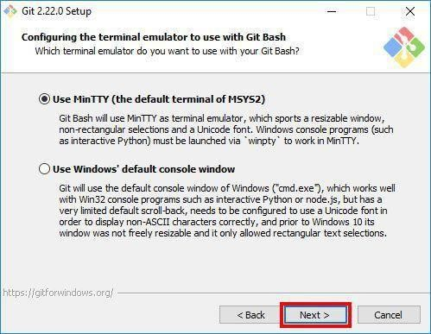

Step 12: Configuring Extra Options

Select the features you want (the default options are fine) and click “Next”.

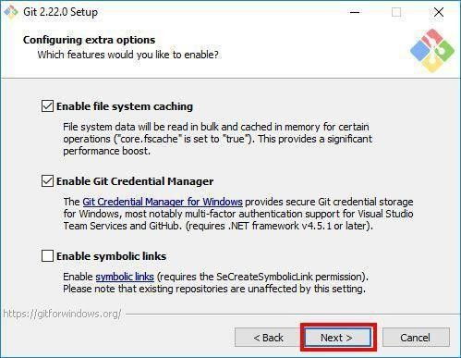

**34**

Step 13: Configuring Extra Options

Enable experimental options if you want. Enabling them allows you to try out newer features that are still in development. I don’t enable this, so I will just proceed by clicking “Install” to start the installation process.

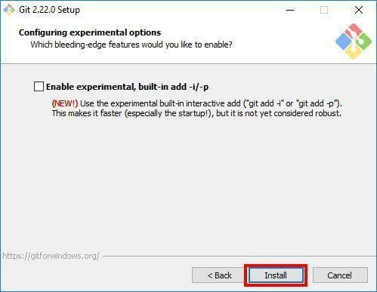

Step 14: Wait for Installation

Now, wait for a few minutes as the Setup Wizard installs Git on your computer.

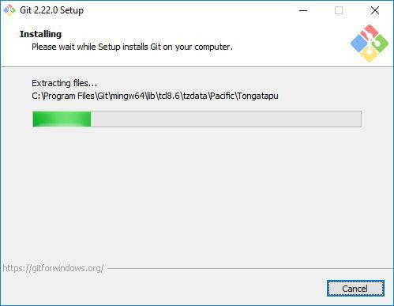

Step 15: Complete the Git Setup Wizard

After the installation has finished, check the “Launch Git Bash” and click “Finish” launching Git Bash.

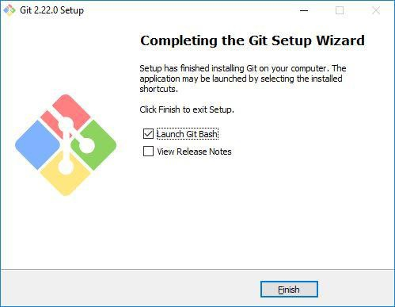

**35**

**Git –version**

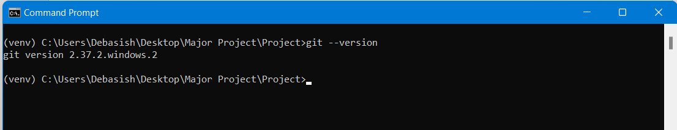Run this command in command prompt to know the git version and git is successfully installed or not.

The Git Bash terminal will now open and you will be able to enter Git and Bash commands.

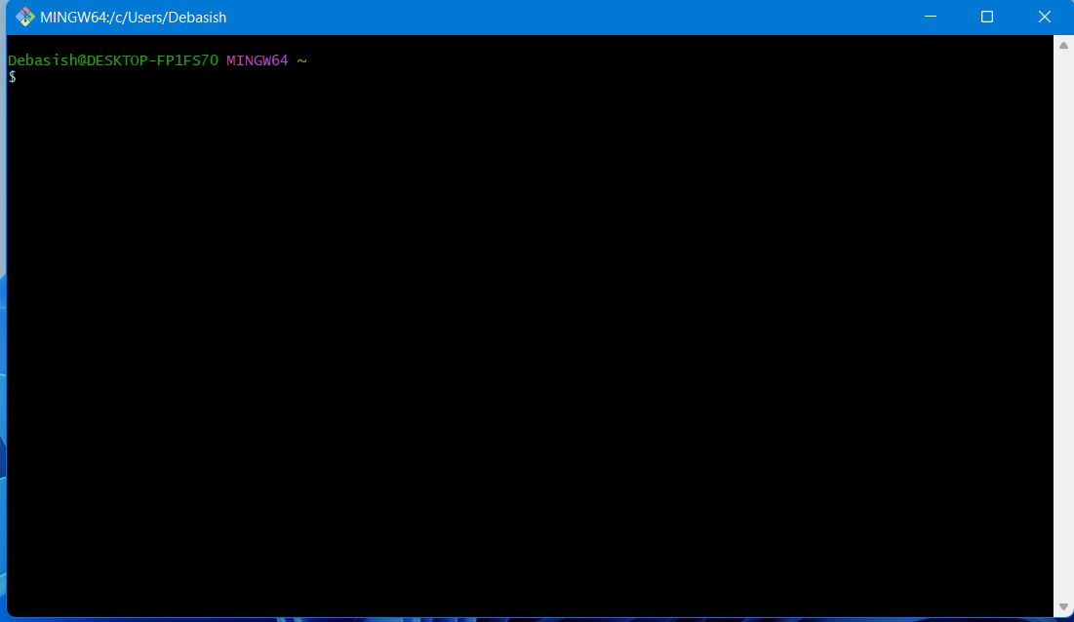

Congratulations on successfully installing Git Bash.

**36**

# CHAPTER-5

## Selected Software or Platform

**What is Visual Studio Code?**

**Visual Studio Code** (famously known as **VS Code**) is a free open-source text editor by Microsoft. VS Code is available for Windows, Linux, and macOS. Although the editor is relatively lightweight, it includes some powerful features that have made VS Code one of the most popular development environment tools in recent times.

**Why we use Visual Studio Code.**

Edit, build, and debug with ease

At its heart, Visual Studio Code features a lightning-fast source code editor, perfect for day-to-day use. With support for hundreds of languages, VS Code helps you be instantly productive with syntax highlighting, bracket-matching, auto-indentation, box-selection, snippets, and more. Intuitive keyboard shortcuts, easy customization and community-contributed keyboard shortcut mappings let you navigate your code with ease.

Make it your own

Customize every feature to your liking and install any number of third-party extensions. While most scenarios work "out of the box" with no configuration, VS Code also grows with you, and we encourage you to optimize your experience to suit your unique needs. VS Code is an open-source project so you can also contribute to the growing and vibrant community on GitHub.

Built with love for the Web

VS Code includes enriched built-in support for Node.js development with JavaScript and TypeScript, powered by the same underlying technologies that drive Visual Studio. VS Code also includes great tooling for web technologies such as JSX/React, HTML, CSS, SCSS, Less, and JSON.

Robust and extensible architecture

Architecturally, Visual Studio Code combines the best of web, native, and language-specific technologies. Using Electron VS Code combines web technologies such as JavaScript and Node.js with the speed and flexibility of native apps. VS Code uses a newer, faster version of the same industrial- strength HTML-based editor that has powered the "Monaco" cloud editor, Internet Explorer's F12 Tools, and other projects. Additionally, VS Code uses a tools service architecture that enables it to integrate with many of the same technologies that power Visual Studio, including Roslyn for .NET, TypeScript, the Visual Studio debugging engine, and more.

**37**

Visual Studio Code includes a public extensibility model that lets developers build and use extensions, and richly customize their edit-build-debug experience.

**How to Developed a Project.**

In every Application Development or Project Development basically Follow Three basic step: -

Frontend

Backend

Database

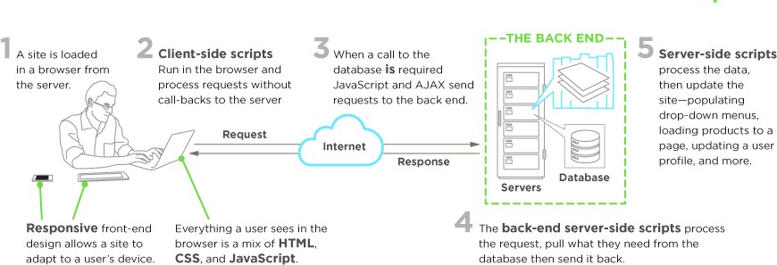

**38**

Frontend Development

**What is Front end Development?**

Everything you see on a website, like buttons, links, animations, and more, were created by a front-end web developer. It is the front-end developer's job to take the vision and design concept from the client and implement it through code.

**39**

**What Skills Do You Need to Become a Front-End Developer?**

The three main languages you need to know well are HTML, CSS, and JavaScript. From there you can focus on frameworks, libraries, and other useful tools.

HTML

HTML stands for Hypertext Markup Language. HTML displays the content on the page like buttons, links, headings, paragraphs, and lists.

CSS

CSS stands for Cascading Style Sheets. CSS is responsible for the style of your web page including colors, layouts, and animations.

JavaScript

JavaScript allows users to interact with the web page. Examples of JavaScript can be found in virtually any web page including the rimedu.com homepage.

For example, when I click on the Menu button at the top of the page, it will open a dropdown list of options. Every time I click on that button, it will toggle back and forth between opening and closing the Menu.

SS Frameworks, Libraries, and Preprocessors

Once you learn the basics of CSS, then you can start to work with different frameworks and libraries. These tools were created as a way to help speed up the development process.

Frameworks like [Bootstrap](https://getbootstrap.com/) and [Tailwind CSS](https://tailwindcss.com/) allow you to add the catalog of classes to your webpage. As a result, you end up with professional and mobile-friendly designs.

There are dozens of options on the market and you don't need to learn them all. It's often helpful to look at jobs in your area and see what technologies they're using. Then you can focus on the most common/in-demand skills.

Here is a list of a few options:

* [Bootstrap](https://getbootstrap.com/)
* [Tailwind CSS](https://tailwindcss.com/)
* [Bulma](https://bulma.io/)
* [Materialize](https://materializecss.com/)
* [Semantic UI](https://semantic-ui.com/)

CSS pre-processors like [Sass](https://sass-lang.com/) and [Less](https://lesscss.org/), allow you to add logic and functionality to your CSS. These tools make your CSS clean and easy to work with.

JavaScript libraries and frameworks

Just like with the CSS libraries and frameworks, there are many options for JavaScript.

It is not necessary to learn them all. Same as above, research job postings in your area to see what libraries and frameworks are being used.

Here are some popular options:

* [React](https://reactjs.org/)
* [Angular](https://angular.io/)
* [Vue](https://vuejs.org/)

These frameworks and libraries allow you to save time and do more with less code. It is possible to get a job specializing in React, Vue, or Angular.

**Frontend Technologies: -**

in our Team member Developed Front Part using some latest Technologies.



html5

css

js

Angualr

js 11

**40**

**What is HTML5?**

HTML stands for Hyper Text Markup Language. It is used to design web pages using a markup language. HTML is an abbreviation of Hypertext and Markup language. Hypertext defines the link between the web pages. The markup language is used to define the text document within the tag which defines the structure of web pages. HTML 5 is the fifth and current version of HTML. It has improved the markup available for documents and has introduced application programming interfaces (API) and Document Object Model(DOM).

**Features:**

* It has introduced new multimedia features which support audio and video controls by using <audio> and <video> tags.
* There are new graphics elements including vector graphics and tags.
* Enrich semantic content by including <header> <footer>, <article>, <section> and

<figure> are added.

* Drag and Drop- The user can grab an object and drag it further dropping it to a new location.
* Geo-location services- It helps to locate the geographical location of a client.
* Web storage facility which provides web application methods to store data on the web browser.
* Uses SQL database to store data offline.
* Allows drawing various shapes like triangle, rectangle, circle, etc.
* Capable of handling incorrect syntax.
* Easy DOCTYPE declaration i.e., <!doctype html>
* Easy character encoding i.e., <meta charset=” UTF-8″>

**What is CSS?**

**C**ascading **S**tyle **S**heets, fondly referred to as CSS, is a simple design language intended to simplify the process of making web pages presentable.

CSS handles the look and feel part of a web page. Using CSS, you can control the colors of the text, the style of fonts, the spacing between paragraphs, how columns are sized and laid out, what background images or colors are used, layout designs, variations in display for different devices and screen sizes as well as a variety of other effects.

CSS is easy to learn and understand but it provides powerful control over the presentation of an HTML document. Most commonly, CSS is combined with the markup languages HTML or XHTML.

**41**

##### Advantages of CSS

* + **CSS saves time** − You can write CSS once and then reuse same sheet in multiple HTML pages. You can define a style for each HTML element and apply it to as many Web pages as you want.
  + **Pages load faster** − If you are using CSS, you do not need to write HTML tag attributes every time. Just write one CSS rule of a tag and apply it to all the occurrences of that tag. So, less code means faster download times.
  + **Easy maintenance** − To make a global change, simply change the style, and all elements in all the web pages will be updated automatically.
  + **Superior styles to HTML** − CSS have a much wider array of attributes than HTML, so you can give a far better look to your HTML page in comparison to HTML attributes.
  + **Multiple Device Compatibility** − Style sheets allow content to be optimized for more than one type of device. By using the same HTML document, different versions of a website can be presented for handheld devices such as PDAs and cell phones or for printing.

**Global web standards** − Now HTML attributes are being deprecated and it is being recommended to use CSS. So it’s a good idea to start using CSS in all the HTML pages to make them compatible to future browsers.

##### What is JavaScript?

JavaScript is a dynamic computer programming language. It is lightweight and most commonly used as a part of web pages, whose implementations allow client-side script to interact with the user and make dynamic pages. It is an interpreted programming language with object-oriented capabilities.

JavaScript was first known as **Live Script,** but Netscape changed its name to JavaScript, possibly because of the excitement being generated by Java. JavaScript made its first appearance in Netscape

2.0 in 1995 with the name **Live Script**. The general-purpose core of the language has been embedded in Netscape, Internet Explorer, and other web browsers.

* JavaScript is a lightweight, interpreted programming language.
* Designed for creating network-centric applications.
* Complementary to and integrated with Java.
* Complementary to and integrated with HTML.
* Open and cross-platform

**42**

##### Client-Side JavaScript

Client-side JavaScript is the most common form of the language. The script should be included in or referenced by an HTML document for the code to be interpreted by the browser.

It means that a web page need not be a static HTML, but can include programs that interact with the user, control the browser, and dynamically create HTML content.

The JavaScript client-side mechanism provides many advantages over traditional CGI server-side scripts. For example, you might use JavaScript to check if the user has entered a valid e-mail address in a form field.

The JavaScript code is executed when the user submits the form, and only if all the entries are valid, they would be submitted to the Web Server.

JavaScript can be used to trap user-initiated events such as button clicks, link navigation, and other actions that the user initiates explicitly or implicitly.

##### Advantages of JavaScript

The merits of using JavaScript are −

* **Less server interaction** − You can validate user input before sending the page off to the server. This saves server traffic, which means less load on your server.
* **Immediate feedback to the visitors** − They don't have to wait for a page reload to see if they have forgotten to enter something.
* **Increased interactivity** − You can create interfaces that react when the user hovers over them with a mouse or activates them via the keyboard.
* **Richer interfaces** − You can use JavaScript to include such items as drag-and-drop components and sliders to give a Rich Interface to your site visitors.

Frameworks like Bootstrap allow you to add the catalogue of classes to your webpage. As a result, you end up with professional and mobile-friendly designs.

There are dozens of options on the market and you don't need to learn them all. It's often helpful to look at jobs in your area and see what technologies they're using. Then you can focus on the most common/in-demand skills.

**43**

**What is Backend Development?**

Back-end development means working on server-side software, which focuses on everything you can’t see on a website. Back-end developers ensure the website performs correctly, focusing on databases, back-end logic, application programming interface (APIs), architecture, and servers. They use code that helps browsers communicate with databases, store, understand, and delete data.

On a team, back-end developers collaborate with front-end developers, product managers, principal architects, and website testers to build the structure of a website or mobile app. Back- end developers must be familiar with many kinds of tools and frameworks, including languages such as Python, Java, and Ruby. They make sure the back-end performs quickly and responsively to front-end user requests.

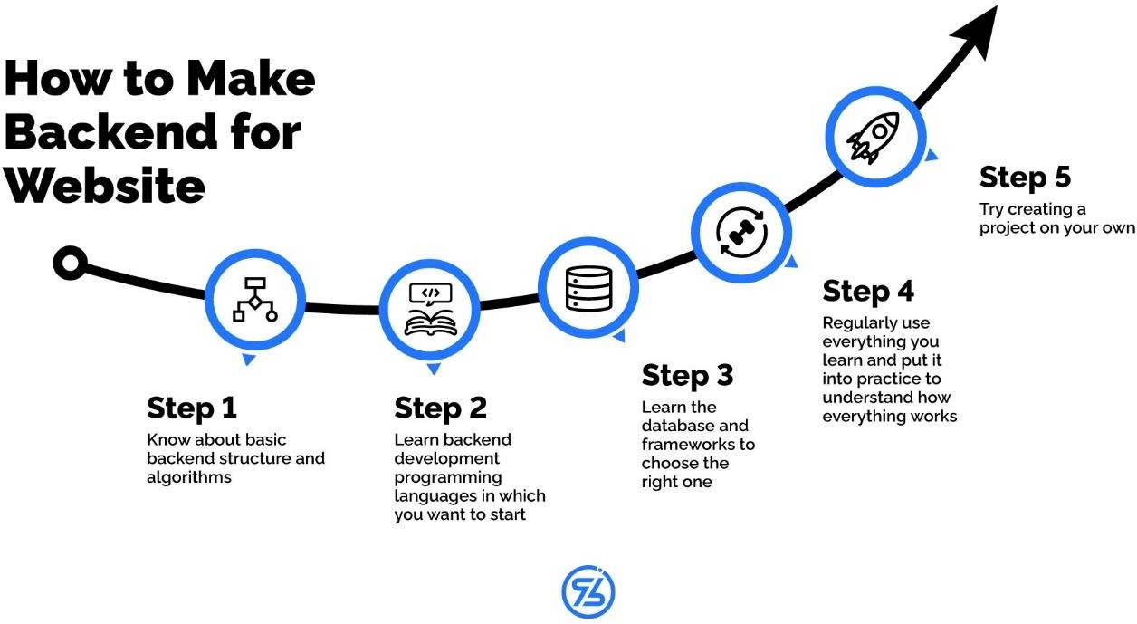

**Backend Technologies**

**44**

**Database**

A **database** is an organized collection of data, so that it can be easily accessed and managed.

A database is a systematic collection of data. They support electronic storage and manipulation of data. Databases make data management easy.

Let us discuss a database example: An online telephone directory uses a database to store data of people, phone numbers, and other contact details. Your electricity service provider uses a database to manage billing, client-related issues, handle fault data, etc.

How to Design a Database?

It is important for a Software Development Professional to know how to design the Database. The main objective of the database design process is to build a robust database.

The database Design is a crucial step in the Software development life cycle (SDLC) that involves Database Operations. The database operations including storing, retrieving and manipulating the data.

The Database Design a specialist job that requires some special Skills in terms of planning the database and then actually building the database using a specific database management system.

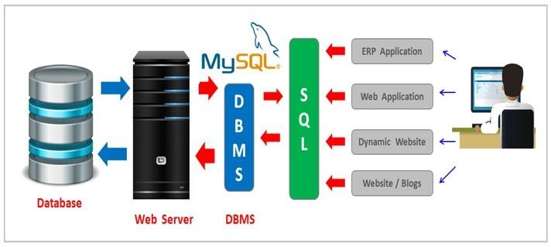

**45**

**Installation process of Mysql Workbench in windows**

**Step 1:**

Download MySQL Workbench

Go to the official MySQL Workbench download page.

Select your operating system (Microsoft Windows).

Click on "Download" under the latest version.

If prompted, you can either log in or click "No thanks, just start my

download.“

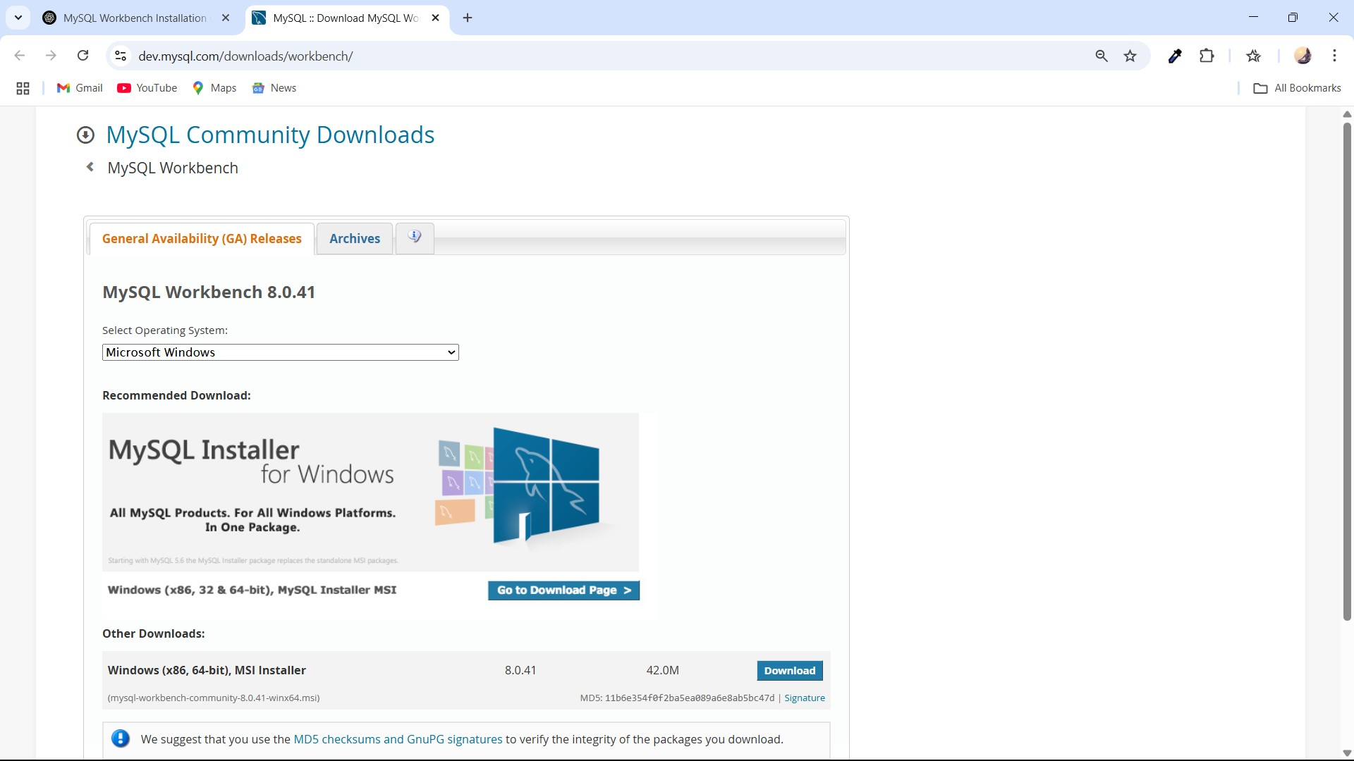

**46**

# Step 2:

Install MySQL Workbench

Open the downloaded .msi installer.

Click Next to begin installation.

Select "Complete" installation and click Next.

Click Install and wait for the installation to

complete.

Click Finish once the installation is done.

# 

# Step 3:

# Open MySQL Workbench

# Search for MySQL Workbench in the Windows Start menu and open it.

**47**

# To setup User Username And Password

# Step 1:

# Open MySQL Workbench

# Launch MySQL Workbench from the Start menu (Windows) or

# Applications (Mac/Linux).

# Step 2: Connect to MySQL Server

# Click on "Local instance MySQL" (or create a new connection).

# If prompted for a password, leave it blank (if not set yet) and click OK.

# If the connection fails, you may need to start MySQL Server:

# Windows: Open Services, find MySQL80 (or similar), and start it.

# Mac/Linux: Run:

# sudo systemctl start mysql

# Step 3: Set a Root Password

# Method 1: Using MySQL Workbench

# In MySQL Workbench, go to Server > Users and Privileges.

# Select root under Users.

# Click Change Password, enter a new password, and confirm.

# Click Apply.

# Method 2: Using SQL Command

# Open a new SQL query tab.

# Run this command:

**48**

**ALTER USER 'root'@'localhost' IDENTIFIED BY 'YourNewPassword'; FLUSH PRIVILEGES;**

Click Execute (the lightning icon).

**Step 4:** Allow Root Access from Anywhere (Optional)

By default, MySQL only allows root access from the local machine. To enable remote access:

**ALTER USER 'root'@'%' IDENTIFIED BY 'YourNewPassword'; FLUSH PRIVILEGES;**

Note: Enabling remote root access can be a security risk. Use it only if necessary.

**Step 5:** Restart MySQL Server

After setting the password, restart the MySQL server:

Windows: Restart the MySQL Service.

Mac/Linux:

# sudo systemctl restart mysql

# Sql Queries:-

**49**

# 

**50**

# 

**51**

# Snapshots of category table -:

# Snapshots of product table -:

**52**

# Snapshots of user table -:

# 

# Software Requirements Specification

# Purpose- The EcoSpark Project aims to develop a sustainable e-commerce platform that offers eco-friendly energy solutions such as solar-powered chargers, power banks, garden lights, inverters, and LED bulbs. The purpose of this project is to bridge the gap between consumers and green energy products by providing a seamless online shopping experience while promoting energy efficiency and sustainability.

# Scope- The EcoSpark Project focuses on developing a fully responsive e-commerce platform dedicated to selling eco-friendly, solar-powered energy solutions such as solar chargers, power banks, garden lights, inverters, and LED bulbs. The project integrates modern web technologies and machine learning to enhance user experience, optimize demand forecasting, and promote sustainable energy consumption.

# Definitions, Acronyms, and Abbreviations

# •SRS – Software Requirements Specification

**53**

# •UI – User Interface

# •DBMS – Database Management System

# •CRUD – Create, Read, Update, Delete

# References

# Web Technologies: HTML, CSS, JavaScript, Java (Spring Boot)

# Database: MySQL

# Overview-

# This document covers functional and non-functional requirements, system features, constraints, and

# dependencies.

# 1. Overall Description

# EcoSpark is an independent web application designed for eco-friendly and solar-powered product shopping. It follows an e-commerce model that allows customers to explore and purchase sustainable energy solutions such as solar chargers, power banks, garden lights, inverters, and LED bulbs.

# 2. Product Functions

# • User Registration and Authentication

# • Product Category

# • Shopping Cart and Checkout

# • Order Management

# 3. User Classes and Characteristics

# • Customers – Browse and purchase eco-friendly items.

# • Admin – Manage products, orders, and edit or Delete Items.

# 4. Operating Environment

# • Frontend: HTML, CSS, JavaScript

# • Backend: Spring Boot (Java)

# • Database: MySQL

# 5. Constraints

# • Responsive design for mobile and desktop.

# • Secure user authentication.

**54**

# 3. Specific Requirements

# 1. Functional Requirements

# • User Management:

# Users can Sign-Up, Sign-In their profiles.

# • Product Management:

# Admin can add, edit, or delete products.

# • Cart and Order Processing:

# Users can add/remove products from the cart.

# 4.System Features

# Registration & Login Users can create accounts and log in.

# 2. Product Catalogue Users can browse fashion products and view detailed descriptions.

# 3. Shopping Cart & Checkout Users can add products to the cart.

# 4. Admin Dashboard Admins can manage products and orders.

# Other Requirements

# • Responsive design for different screen sizes.

**55**

# CHAPTER-7

**SYSTEM DESIGN**

**System Requirements Definition**

**56**

System requirement definitions specify what the system should do, its functionality and its essential and desirable system properties. The techniques applied to elicit and collect information in

order to create system specifications and requirement definitions involve consultations, interviews, requirements workshop with customers and end users. The objective of the requirements definition phase is to derive the two types of requirement:

Functional requirements

They define the basic functions that the system must provide and focus on the need goals of the

end users.

**Use-case Diagram**

A use case diagram at its simplest is a representation of a user’s interaction with the system that shows the relationship between the user and the different use cases in which the user is involved. In our system User will interact with use cases like Capture Image, Audio Input, Save text, Retrieve Text, Audio output

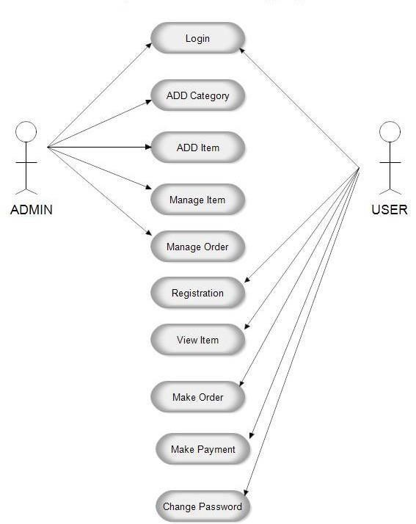

**Data-flow Diagram**

A data-flow diagram is a way representing a flow of a data of a process or a system. The DFD also provides information about the outputs and inputs of each entity and the process itself. Given below is Level 0 Level 1 and Level 2 DFD of system.

**57**

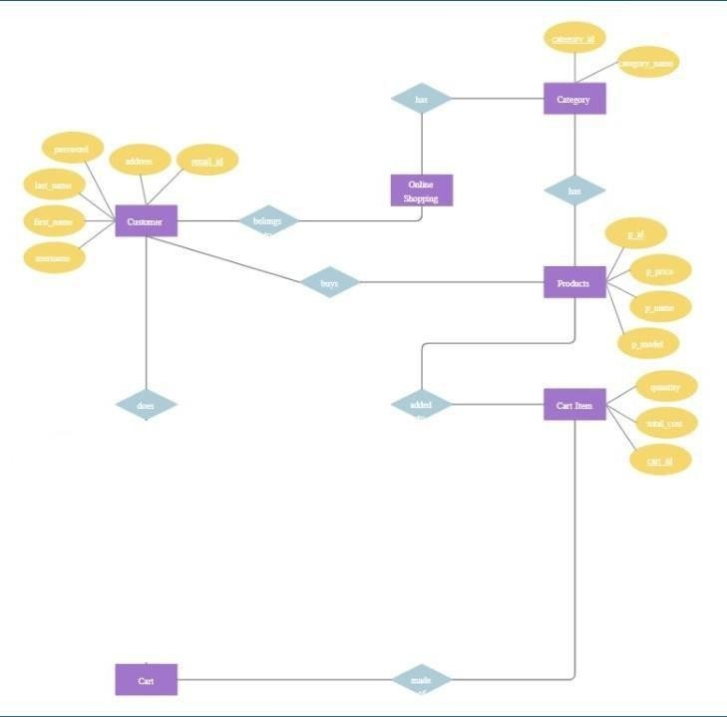

**ER diagram**

**System requirements (non-functional requirements)**

These are non-functional system properties such as availability, performance and safety etc. They define functions of a system, services and operational constraints in detail.

**58**

# CHAPTER-8

**Coding**

**59**

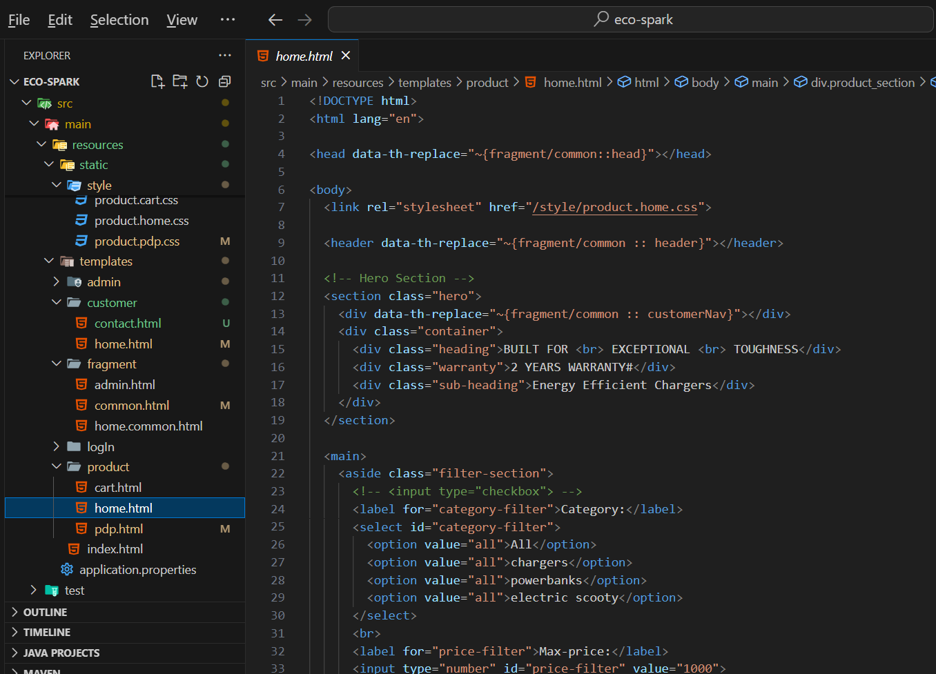

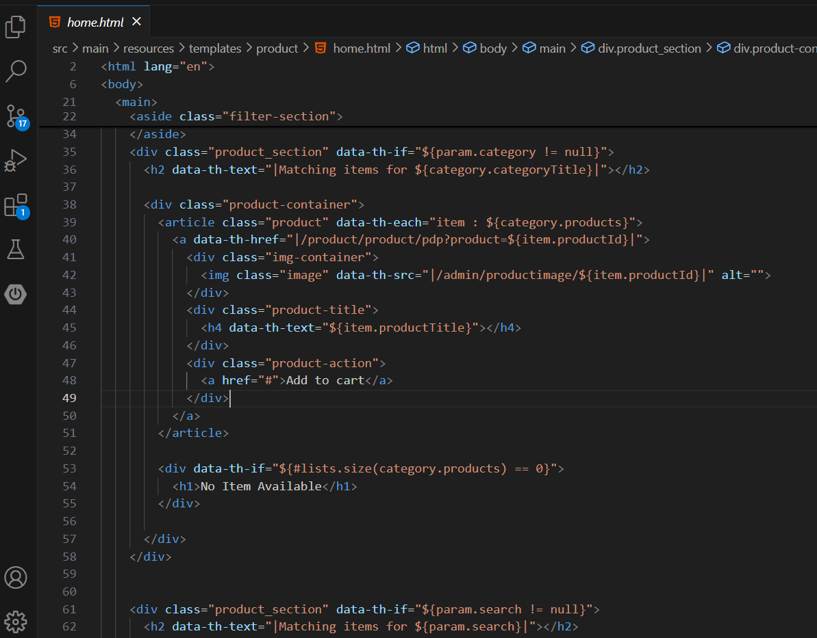

**60**

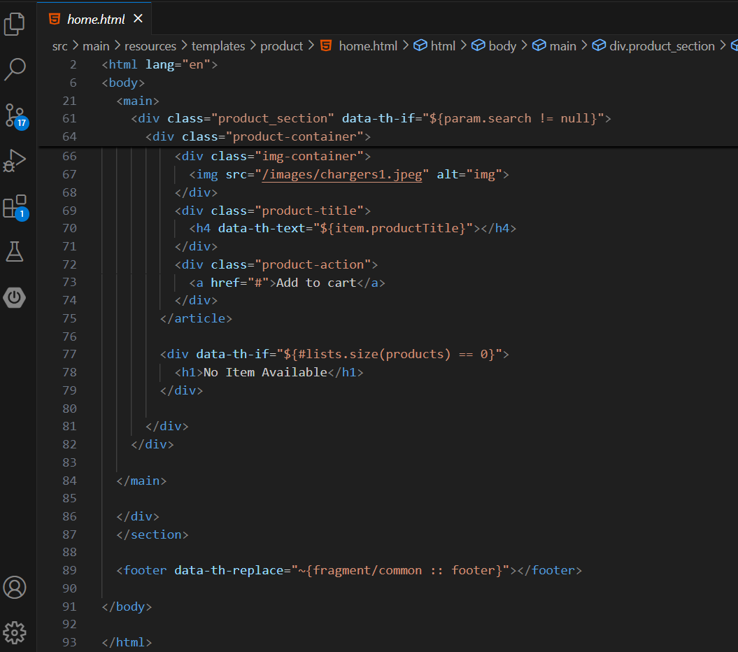

**61**

# Snapshot of homepage-:

**62**

# 

**63**

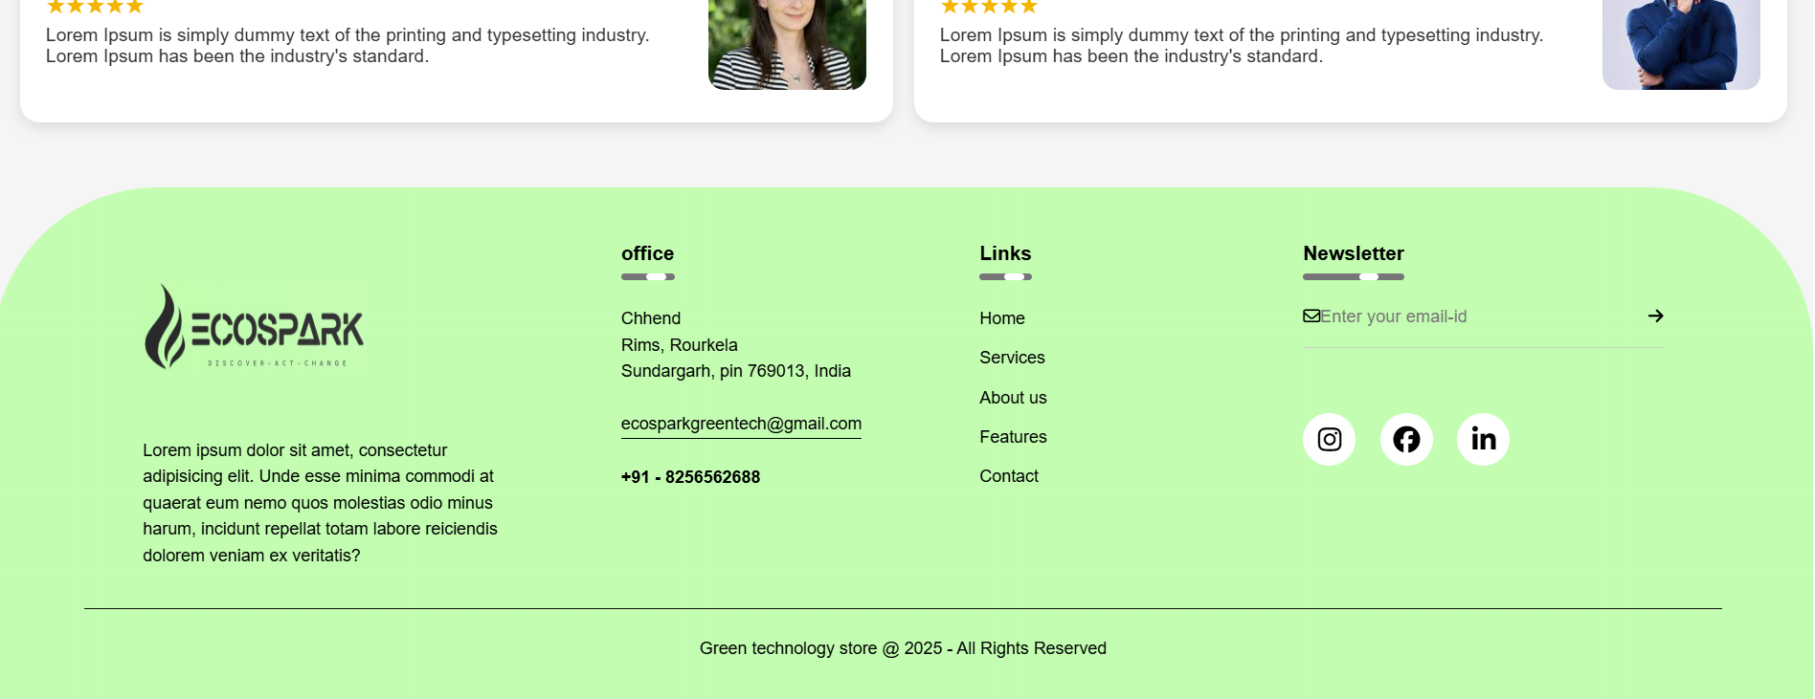

**64**

**Admin Dashboard-:**

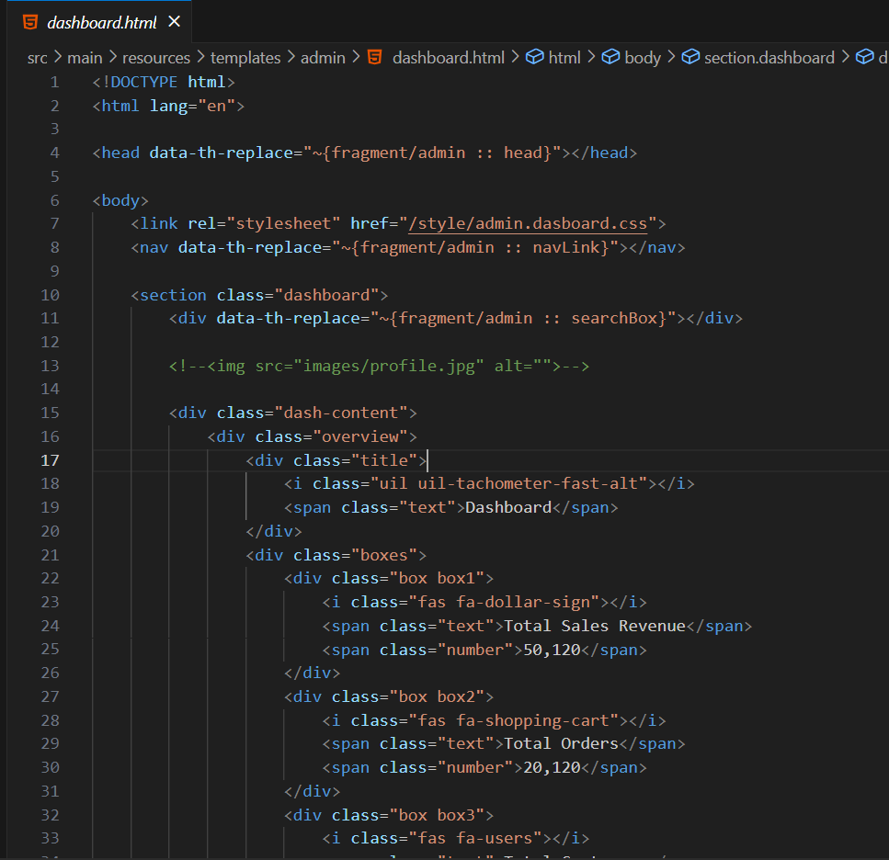

**65**

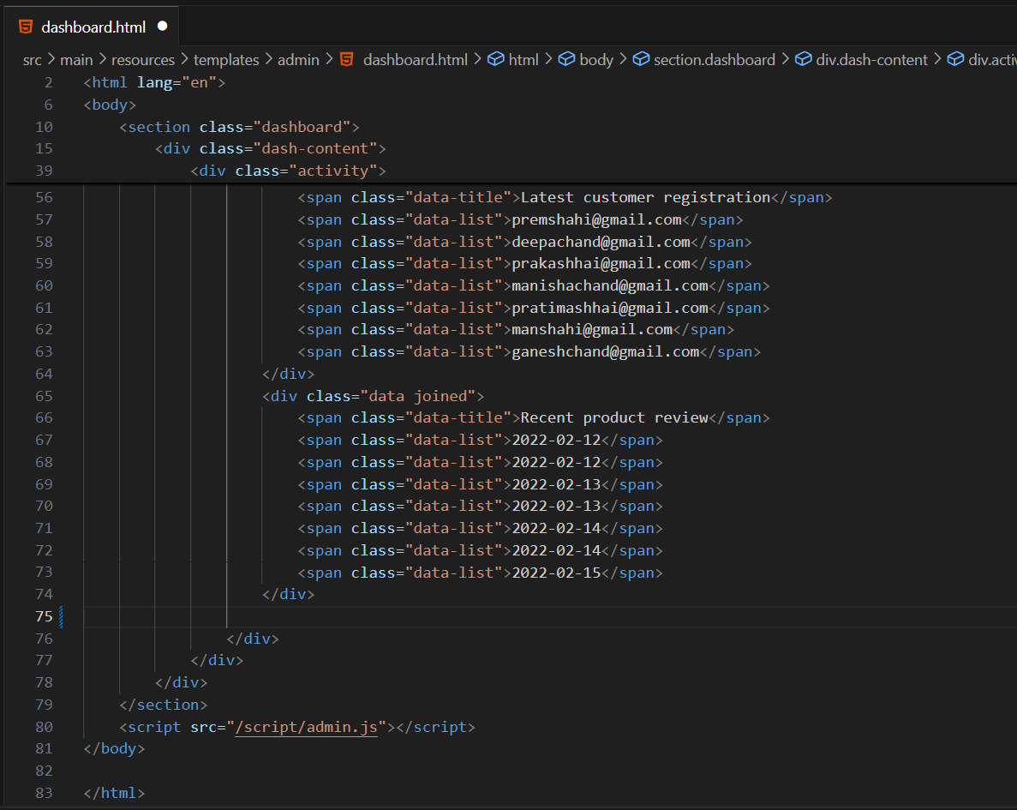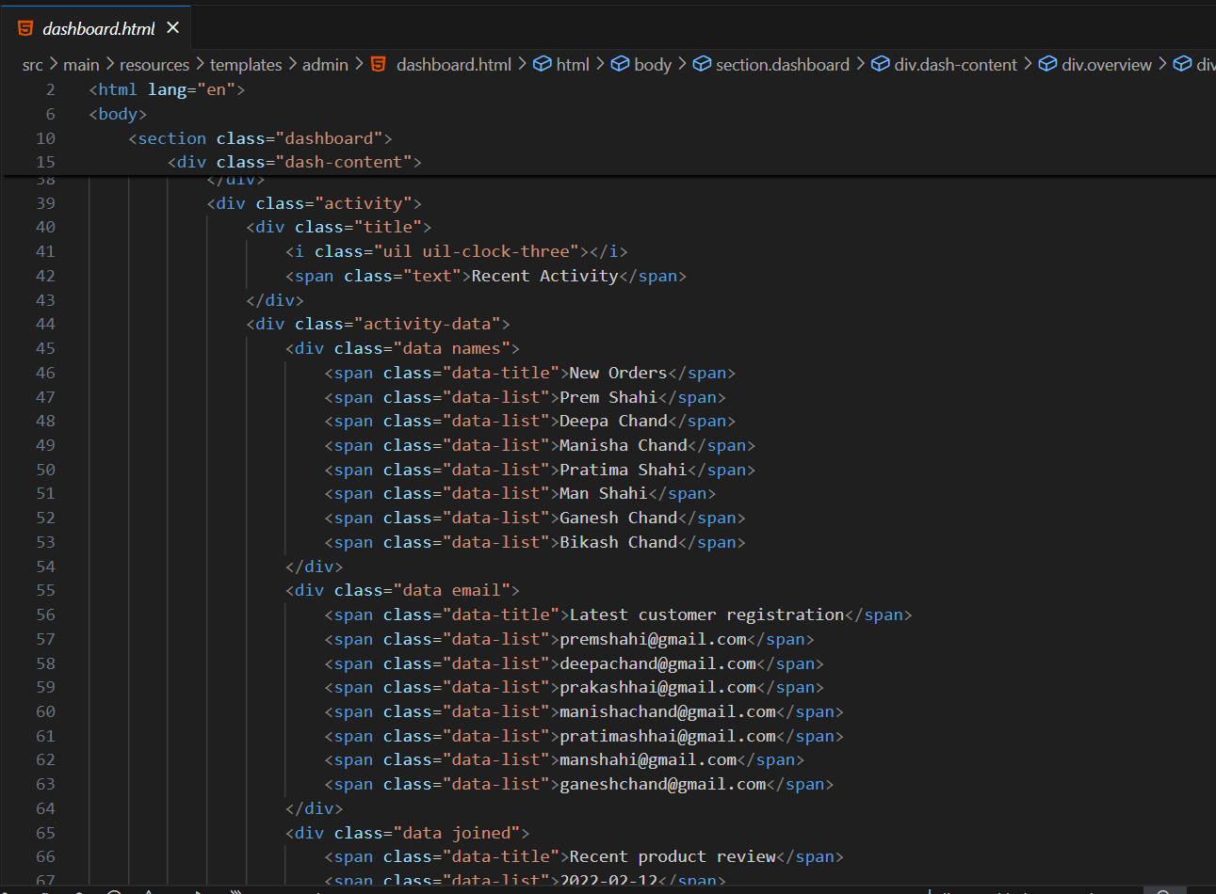

**66**

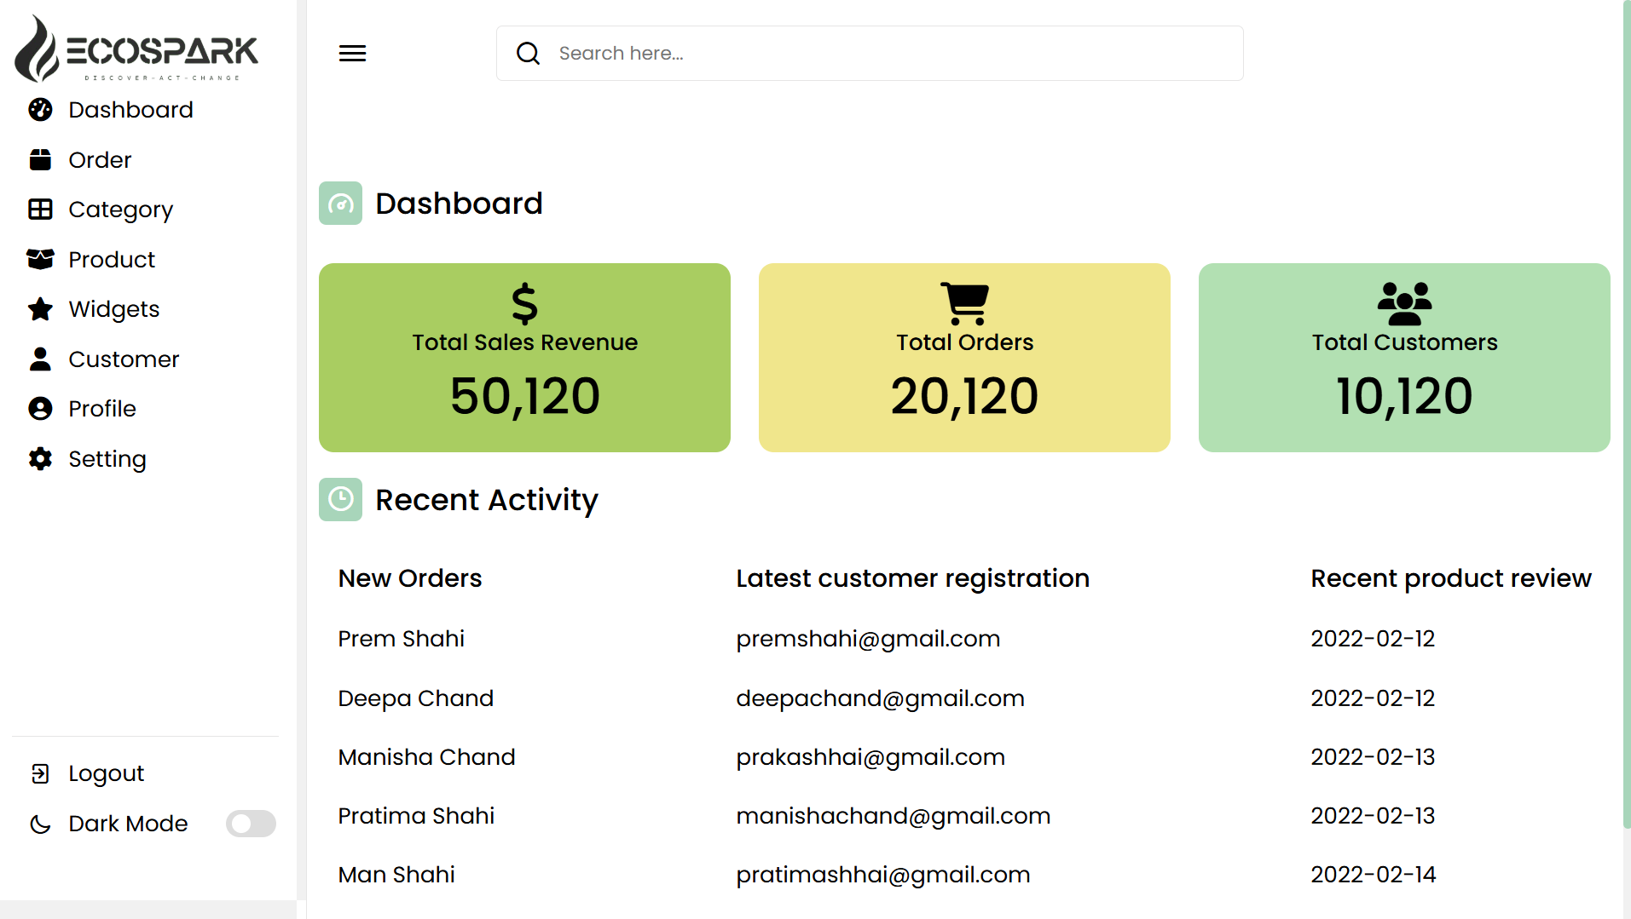**Snapshot of admin dashboard-:**

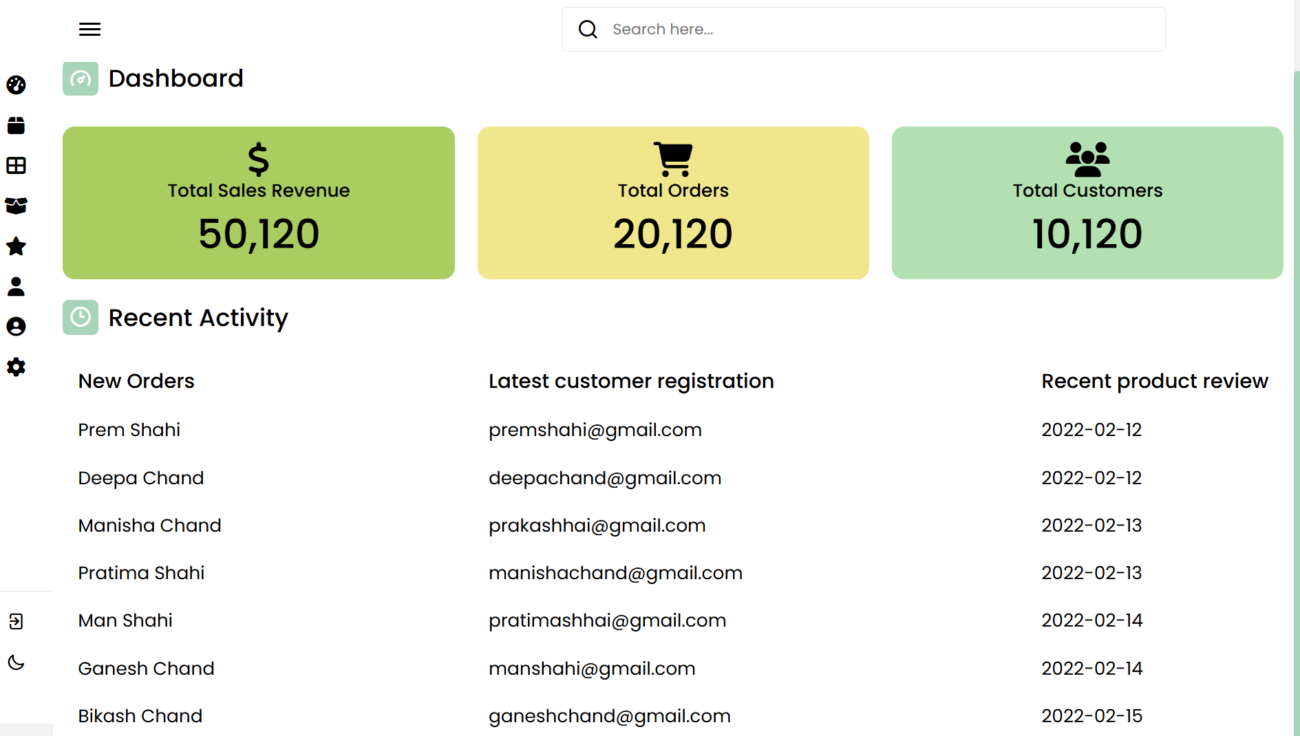

**67**

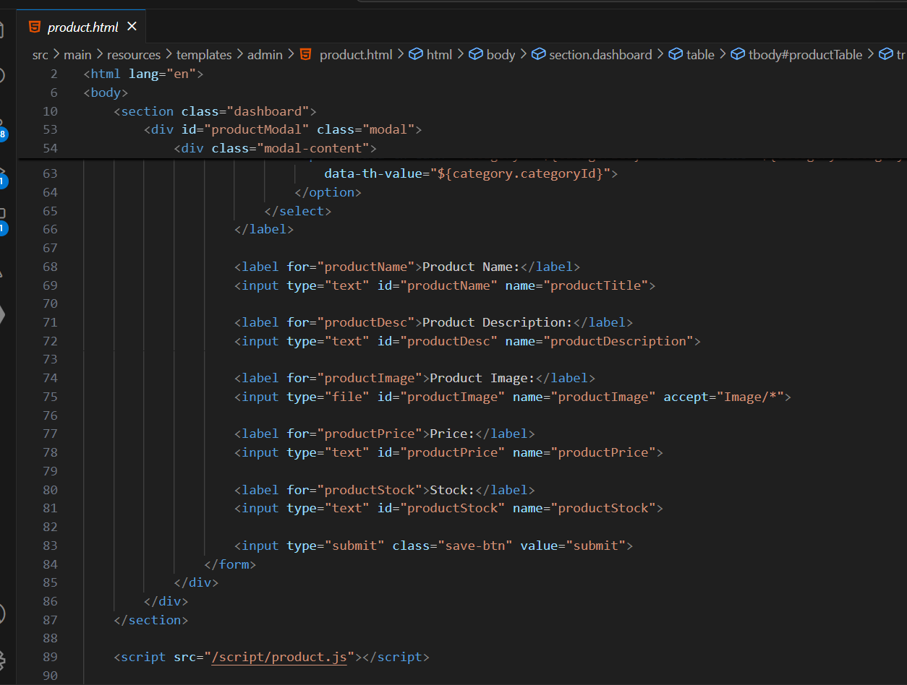**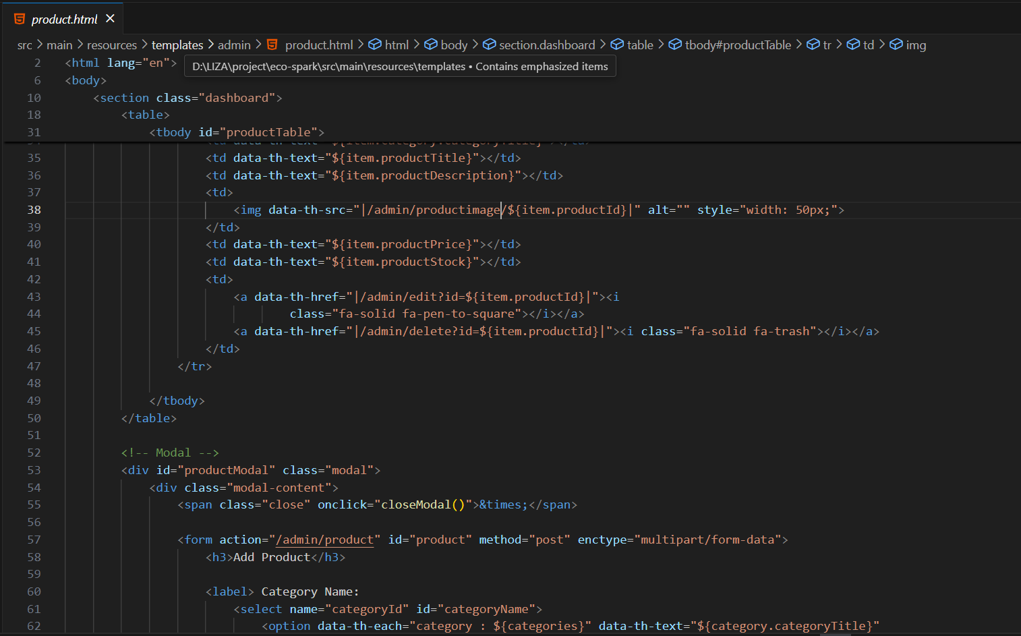Product Dashboard- :**

**68**

**Snapshots of product in admin dashboard-:**

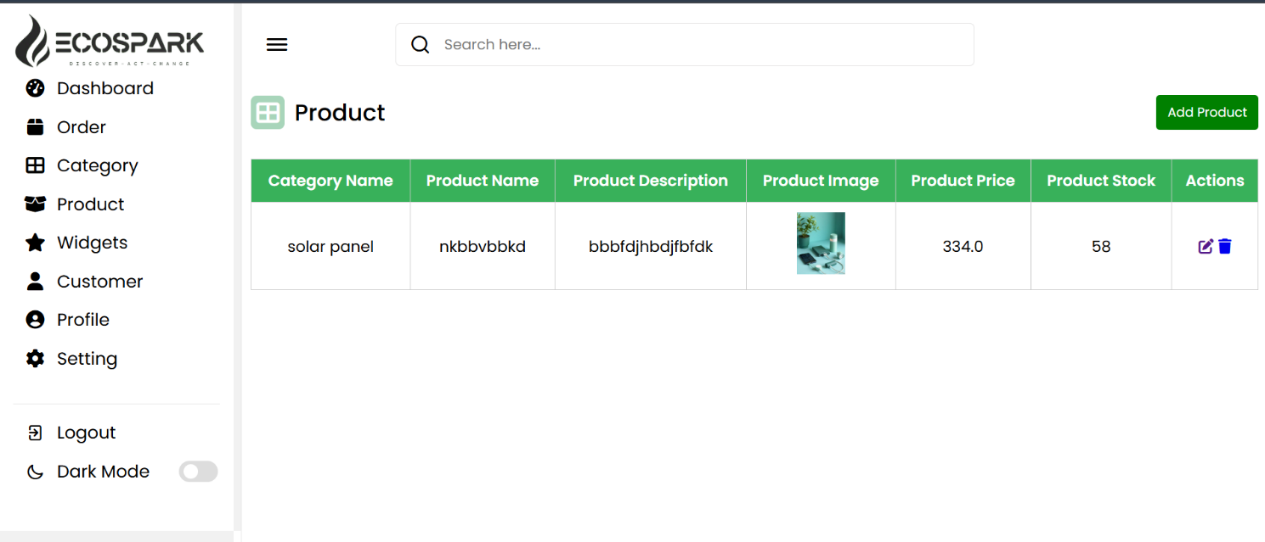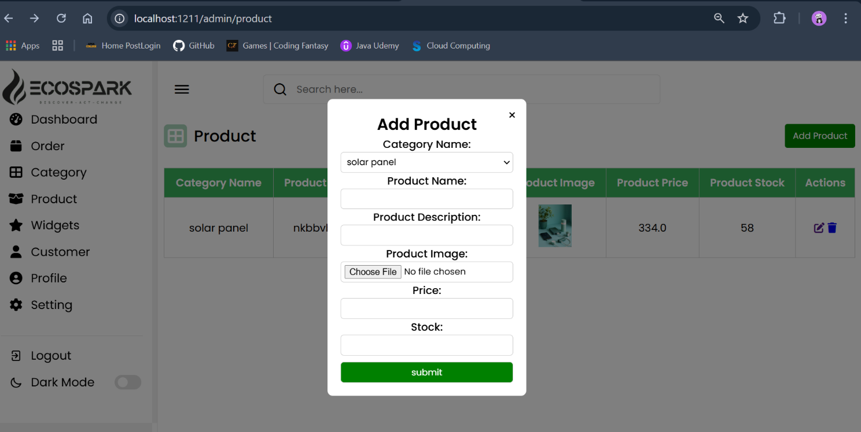

**69**

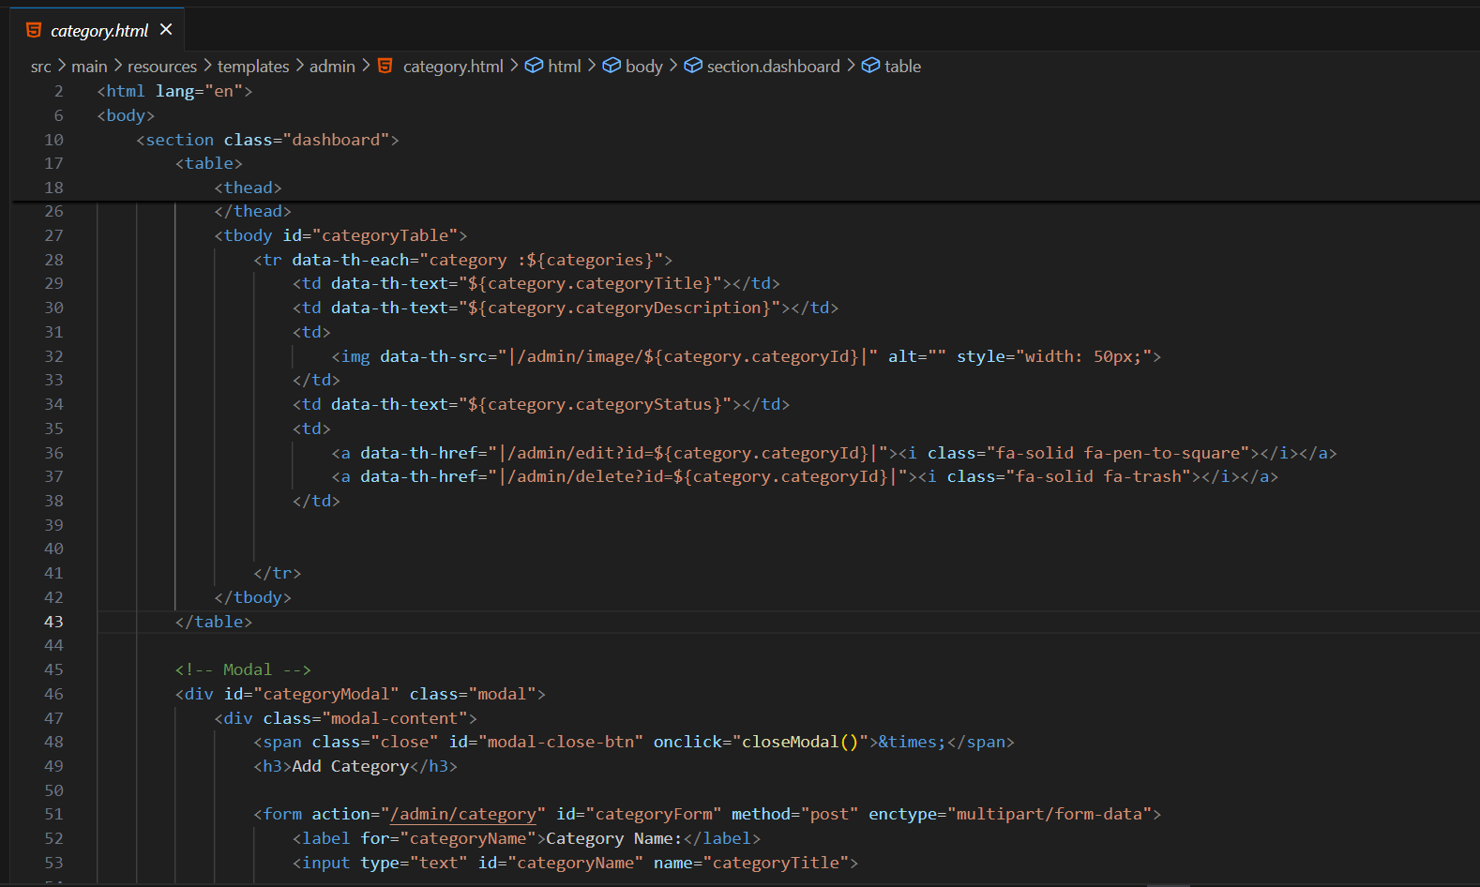**Category on admin dashboard**

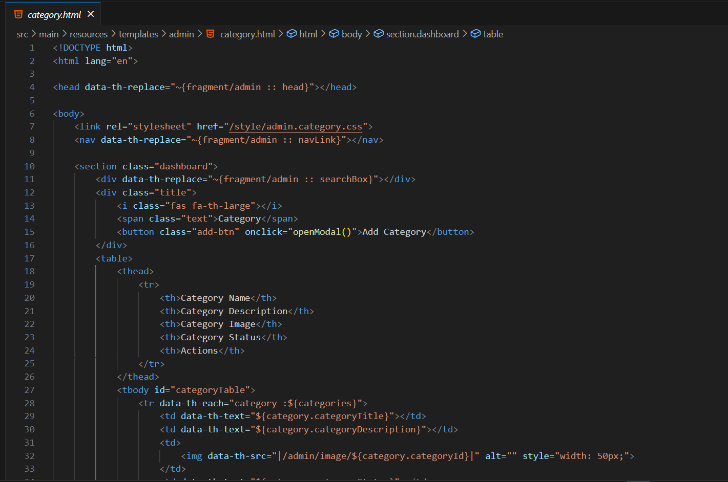

**70**

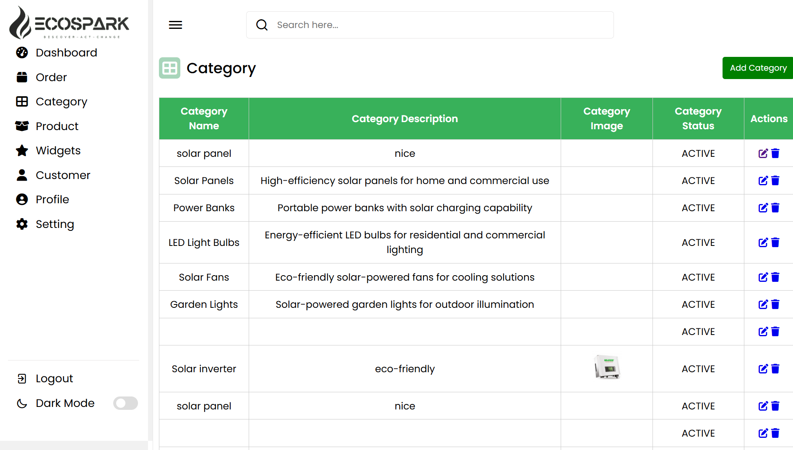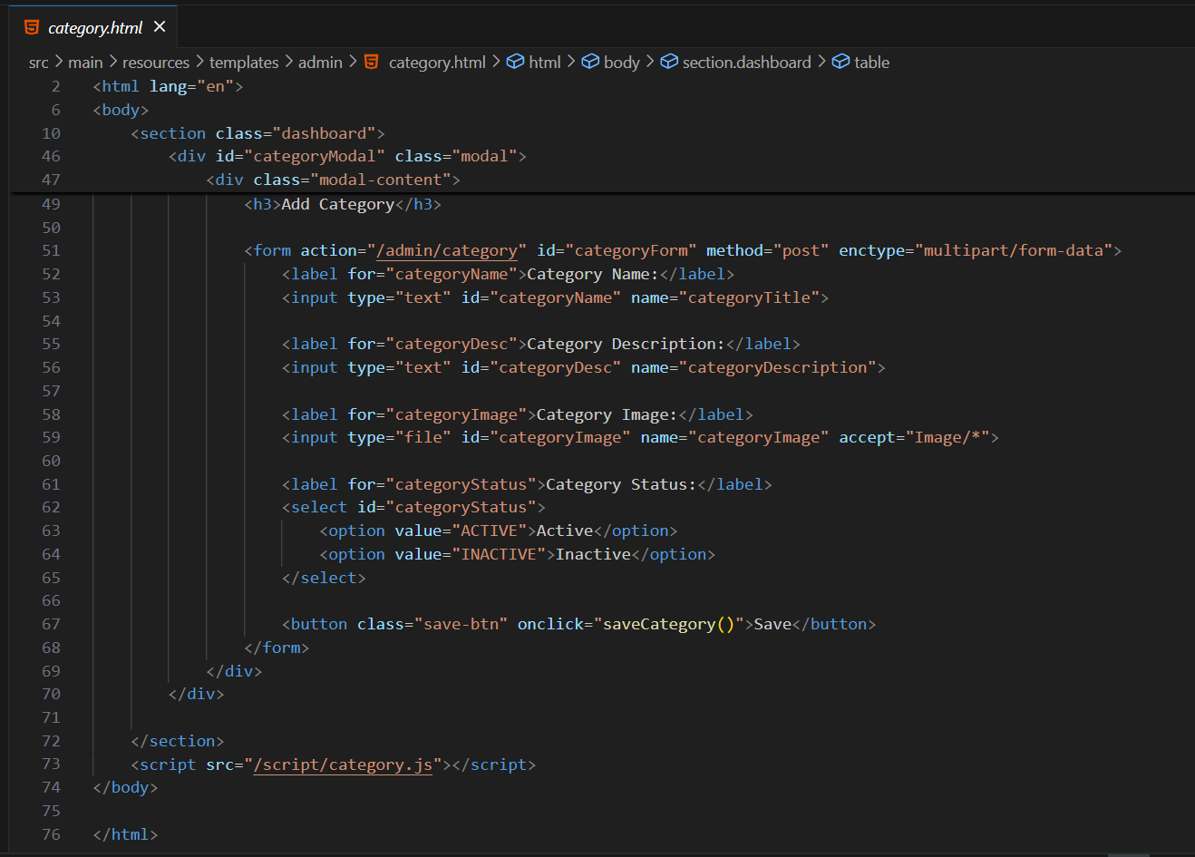**Snapshots -:**

**71**

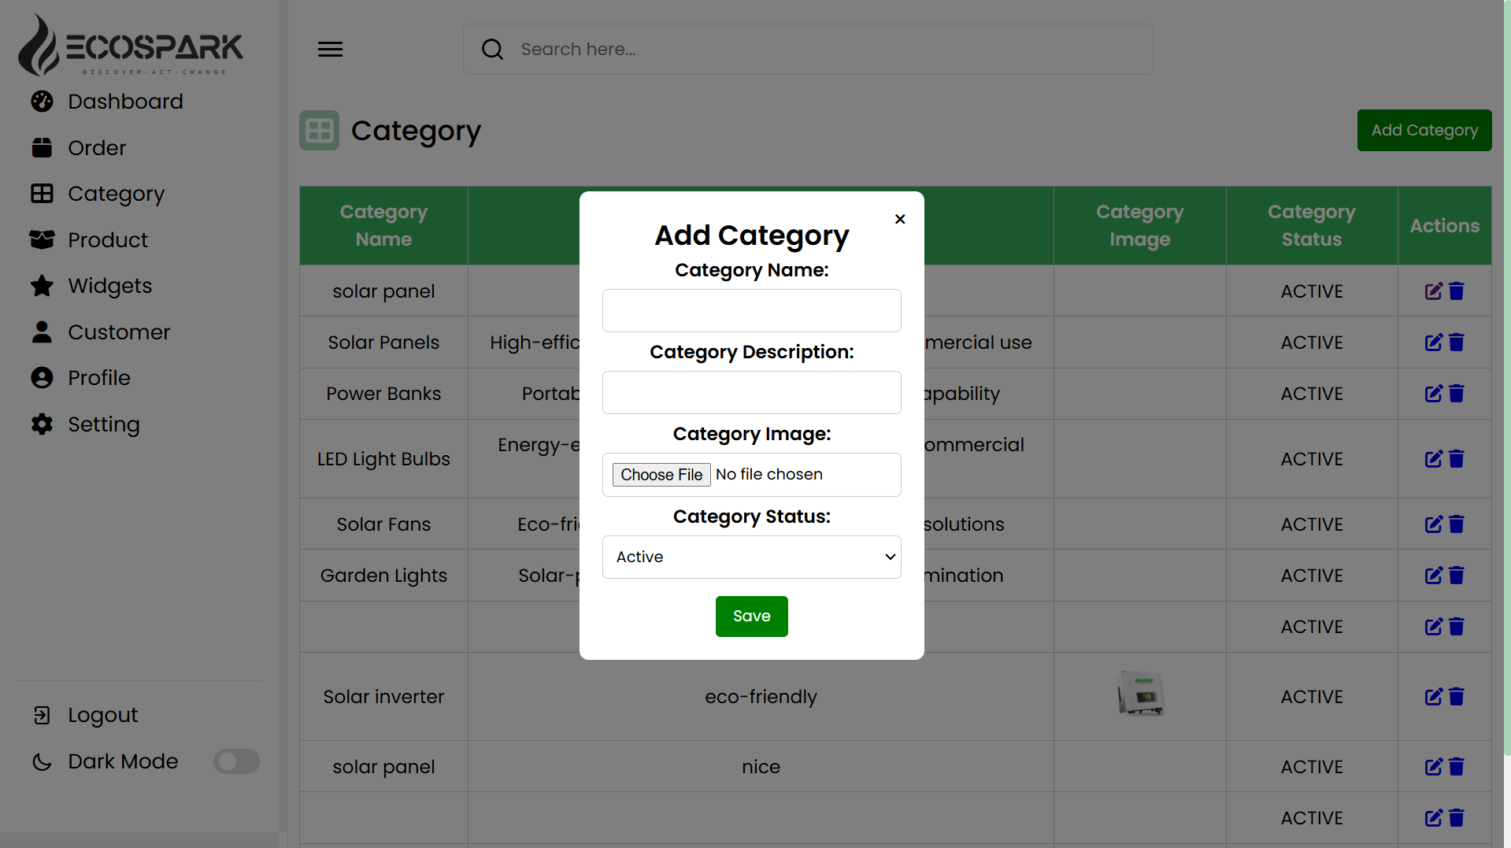

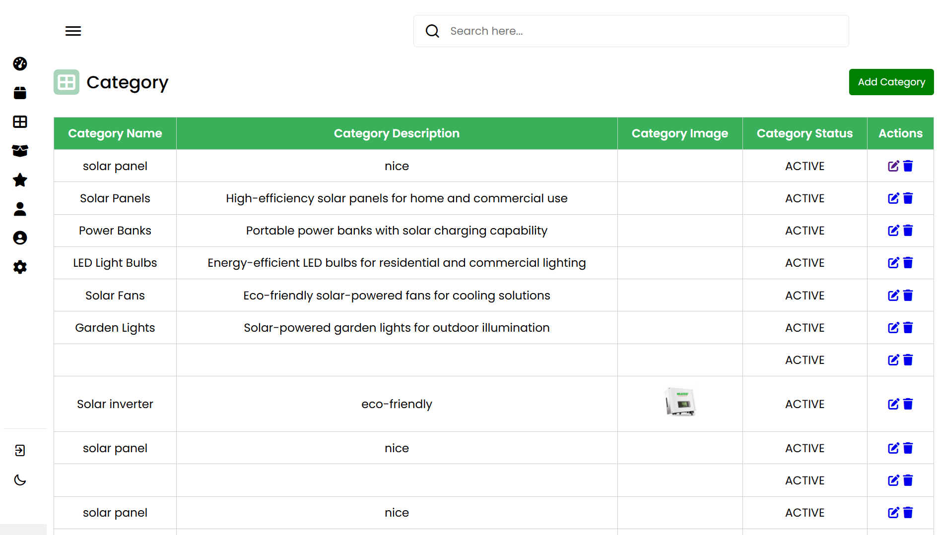

**72**

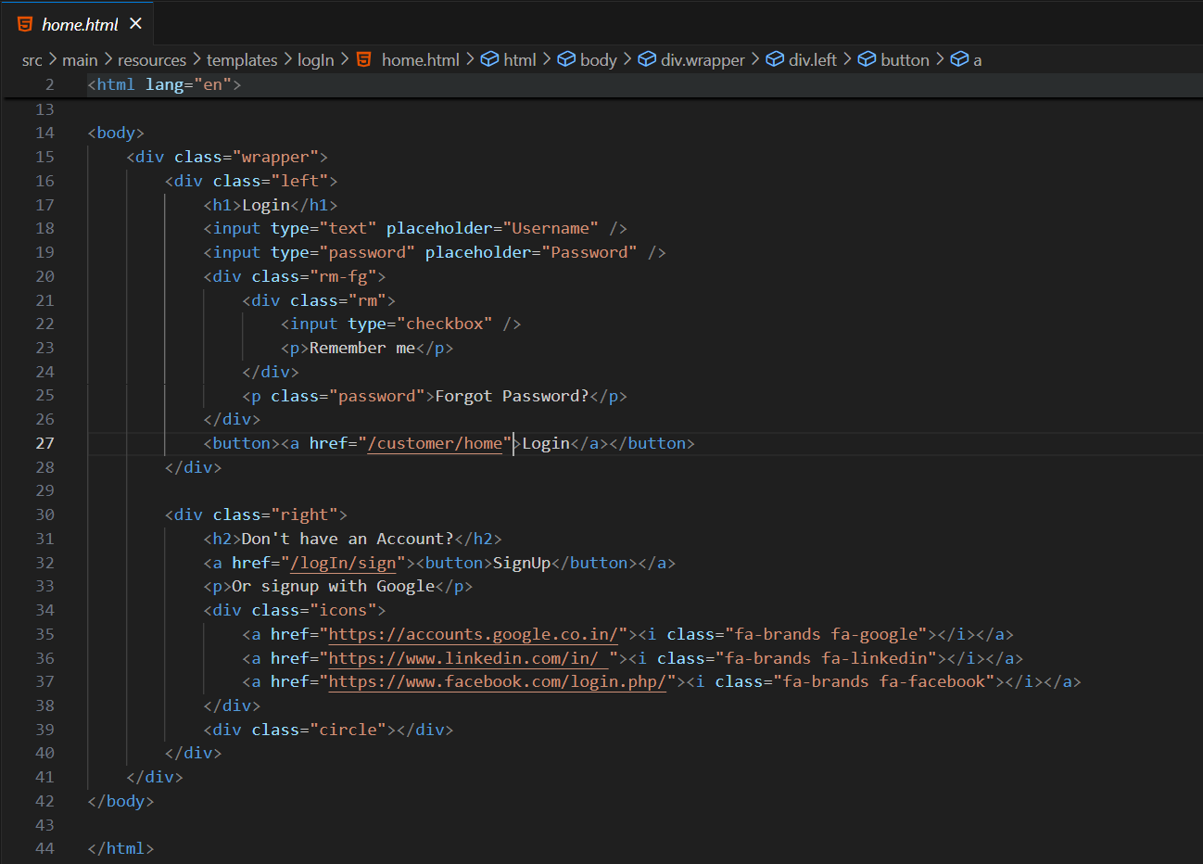**Sign-In**

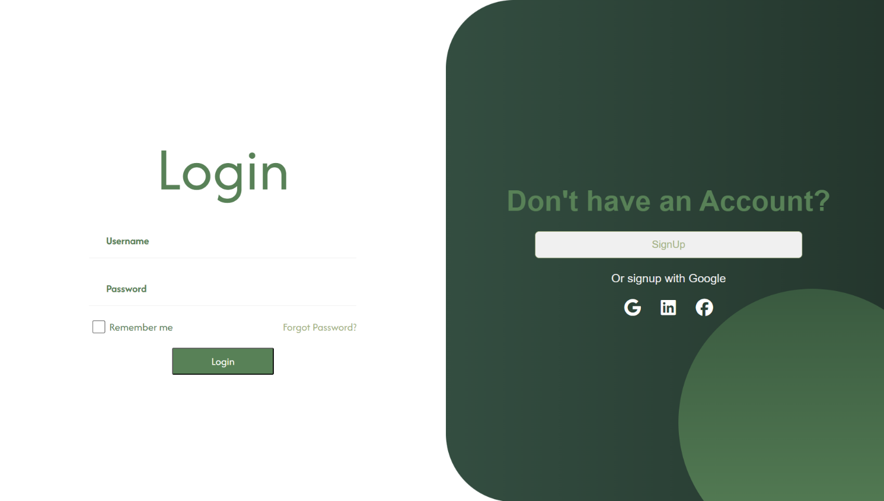

**73**

**Sign-up-:**

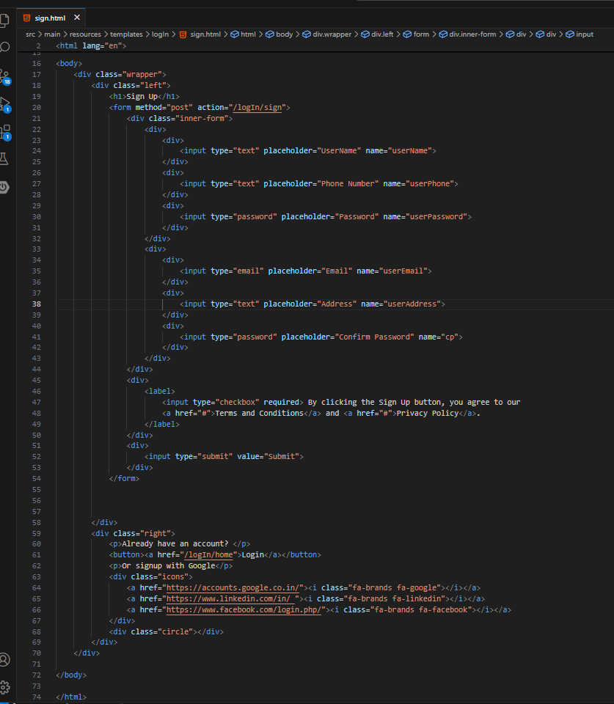

**74**

**Snapshots of sign-up-:**

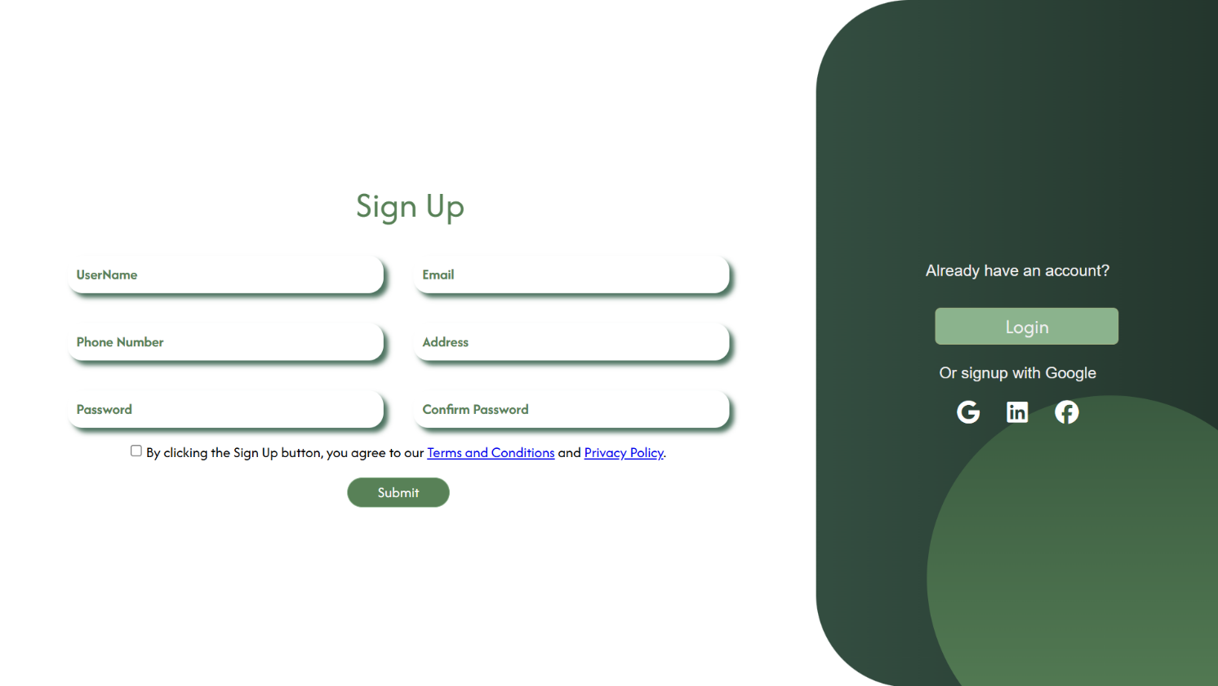

**75**

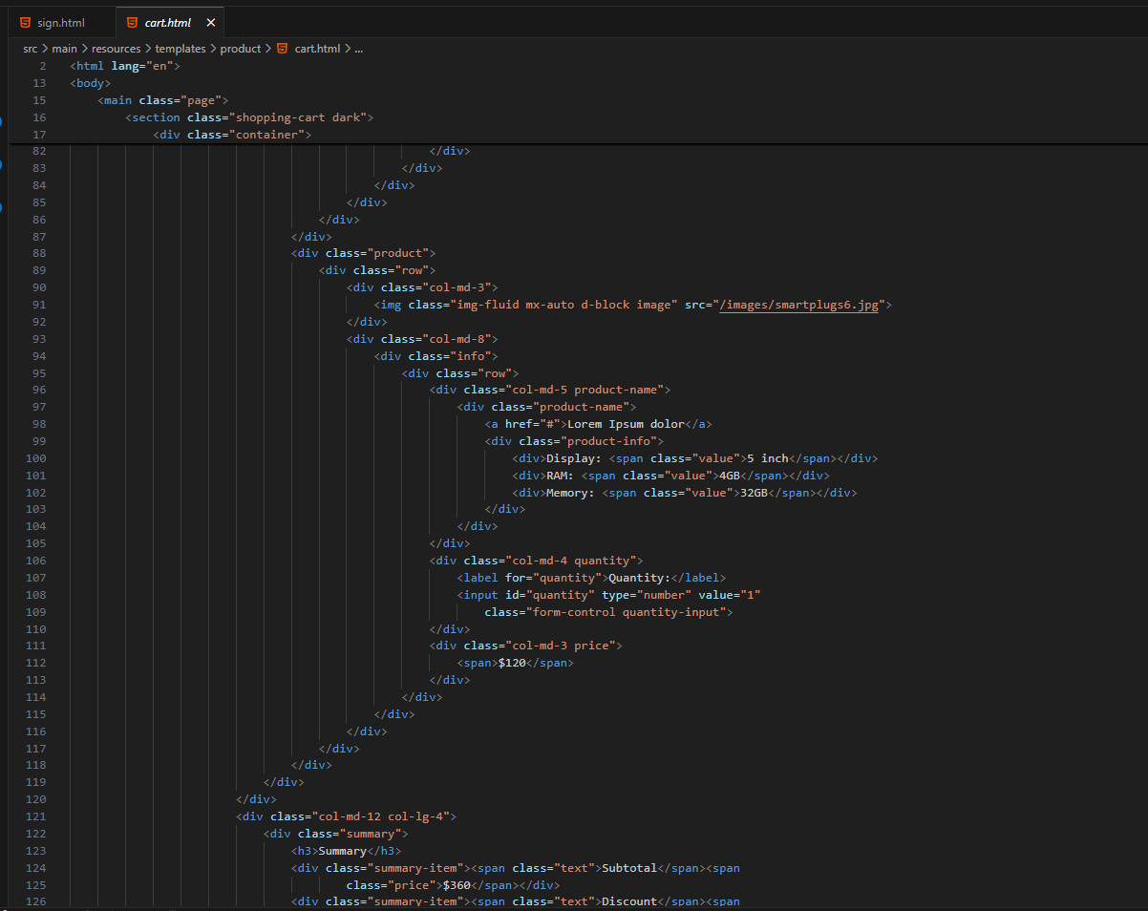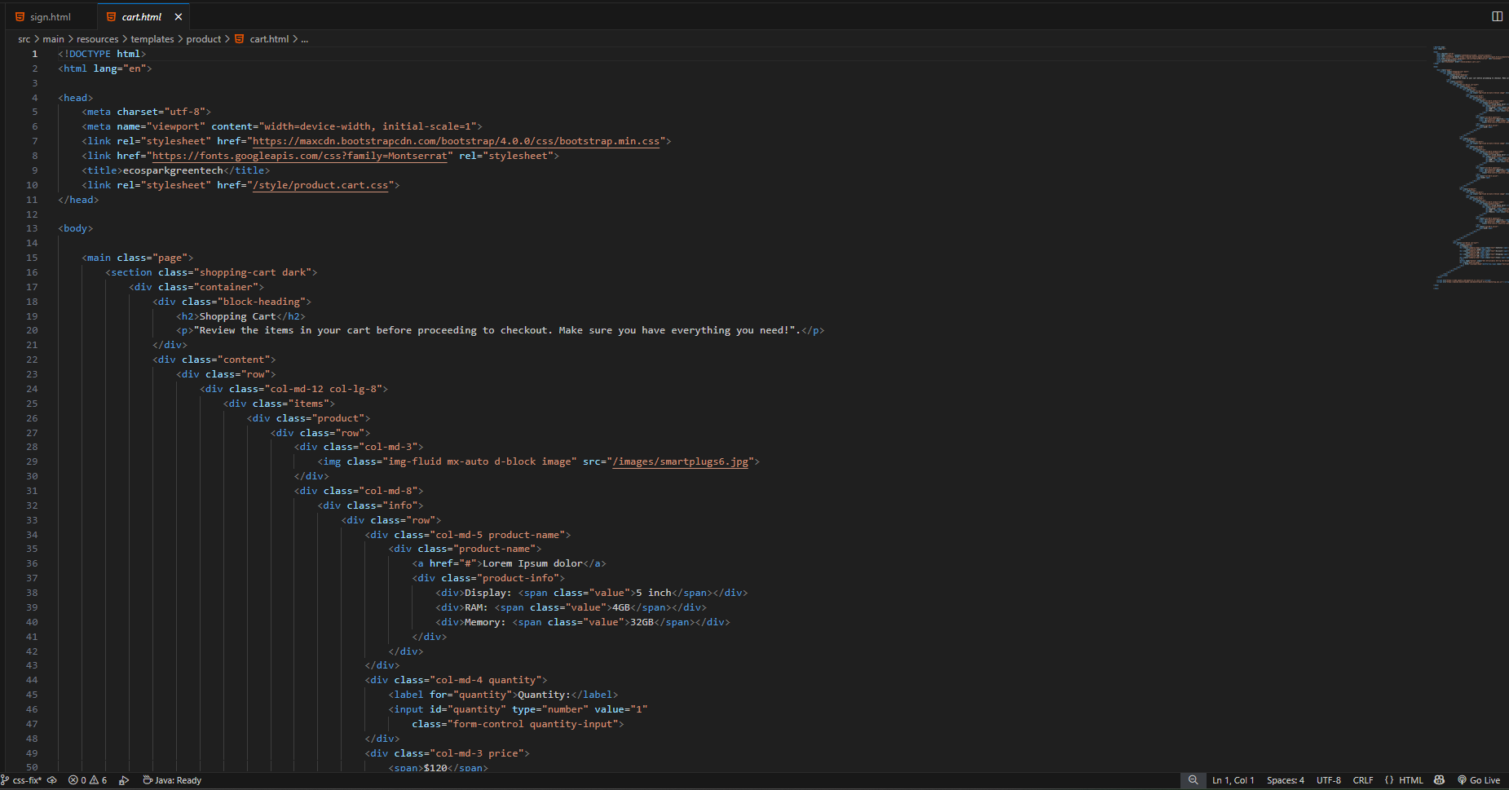**Cart page**

**76**

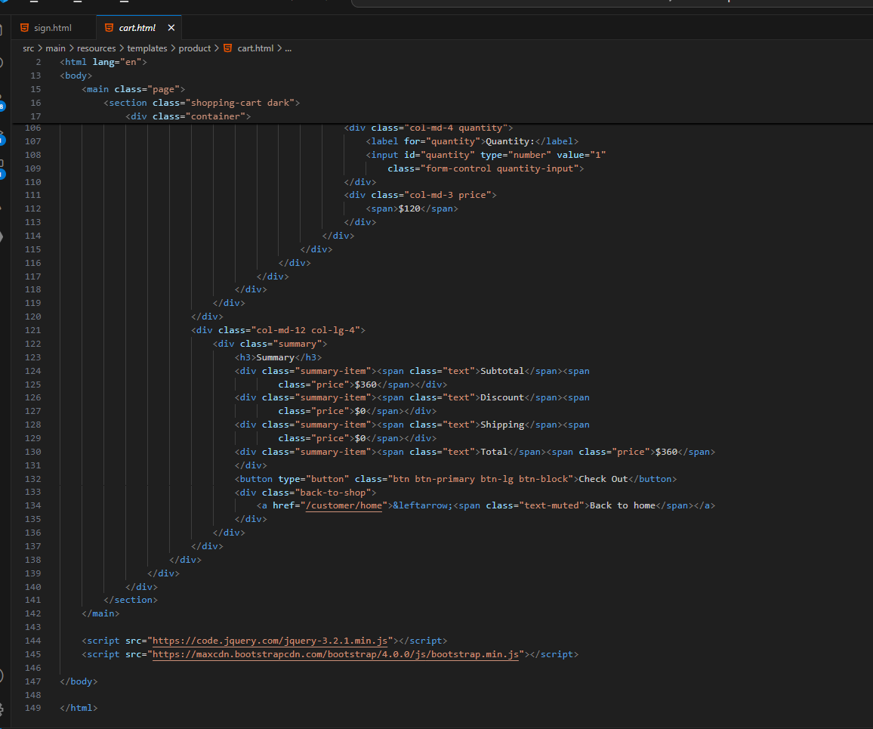

**77**

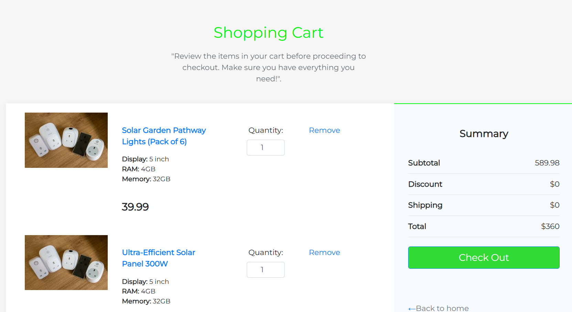**Snapshots-:**

**78**

# CHAPTER-9

### System Testing

**System Testing**

System testing is a level of software testing where a complete and integrated soft- ware is tested. The purpose of this test is to evaluate the system’s compliance with the specified require.

Test Cases and Test Results

|  |  |  |  |  |
| --- | --- | --- | --- | --- |
| **Test**  **ID** | **Test Case Title** | **Test Condition** | **System Behavior** | **Expected Result** |
| T01 | choose company | company chosen | analysing database | company selected |
| T02 | select open and  close date | dates to get selected | analysing database | dates selected |
| T03 | prediction result | analysing result | analysing database | graph prediction |

Sample of a Test Case

**Title**: Predicted Result – User enters a particular company stock.

**Description:** A user should be able to successfully able to collect information regarding the company stock.

Assumption:A user is handy to use the software. Test Steps: -

1. Navigate to our Stock Website
2. In the ‘Company Stock ‘filed, enter the company name of for which

You want to buy the stock.

1. Click the Next Button.
2. Enter the Open and Close date of the company which you want.

s

**79**

**Expected Result**: A page displaying the graphical image of the predicted result should load, showing any new message at the top of the page.

**Actual Result:** Graph with predicted result is being displayed.

Write here description upload the image of result Software Quality Attributes

Availability-1 : The system shall be available to users all the time. Availability-2 : The system shall always have something to function and always pop up error messages in case of component failure.

Efficiency-1 : The system shall generate the predicted price with an accuracy.

Efficiency-2 : The system shall provide the right tools to support all its features.

**80**

# CHAPTER-10

### Conclusion and Future Scope

**Conclusion**

The EcoSpark e-commerce platform is designed to provide a seamless and efficient online shopping experience for eco-friendly products. By leveraging advanced technologies such as machine learning for demand forecasting and optimizing inventory management, EcoSpark enhances its supply chain efficiency and improves customer satisfaction.

Through the development of a robust web application, we have integrated essential features such as user authentication, product management, secure payment processing, and an intuitive user interface. The project also ensures data security, scalability, and responsiveness, making it adaptable to future business growth.

In conclusion, the EcoSpark platform not only promotes sustainable shopping but also serves as a model for eco-friendly businesses looking to integrate smart technology into their operations. Future enhancements may include AI-powered product recommendations, blockchain-based supply chain tracking, and integration with renewable energy monitoring systems to further improve sustainability efforts.

**Future Scope**

1. AI-Powered Recommendations – Personalized product suggestions using machine learning.
2. Smart Energy Analytics – AI-driven insights for energy-efficient product usage.
3. Mobile App Development – Enhanced user experience with voice search and chatbots.
4. Secure Payment Options – Biometric authentication and cryptocurrency support.
5. Sustainable Logistics – Green packaging and carbon-neutral deliveries.
6. Community Engagement – Social platform for eco-friendly tips and discussions.

**81**

These enhancements will drive EcoSpark’s growth, making it a leader in sustainable e-commerce.

# CHAPTER-12

## References

* *Google*
* *ChatGPT*
* *Java Technocrat, BBSR (*[*https://www.javatechnocrat.com/*](https://www.javatechnocrat.com/)*)*
* *W3school (*[*https://www.w3schools.com/MySQL/default.asp*](https://www.w3schools.com/MySQL/default.asp)*)*
* *GeeksforGeeks (*[*https://www.geeksforgeeks.org/spring/*](https://www.geeksforgeeks.org/spring/)*)*
* *Gemini*
* *Bajaj Electricals*

*(*[*https://shop.bajajelectricals.com/*](https://shop.bajajelectricals.com/)*)*

* ***UN Environment Programme (2021).*** *Sustainable Consumption and Production Policies in E-commerce.*
* ***EarthHero***

***(***[***https://earthhero.com/?srsltid=AfmBOoq1xeDox7vCjkPvoxypd2NtzKHUXbpTcCBsXF_E6y_cZALImz_4***](https://earthhero.com/?srsltid=AfmBOoq1xeDox7vCjkPvoxypd2NtzKHUXbpTcCBsXF_E6y_cZALImz_4)***)***

* *Green Eco Dream*

*(*[*https://greenecodream.com/*](https://greenecodream.com/)*)*

**82**